emergency Operations plan *DRAFT*

****Base Plan

**03/10/2025**



TABLE OF CONTENTS

CONFIDENTIALITY NOTICE 7

City & COUNTY ADOPTION / PROCLAMATION OF PLAN 8

RECORD OF CHANGES 9

RECORD OF DISTRIBUTION 9

EXECUTIVE SUMMARY 10

PLANNING AGENCIES 12

PRIMARY AGENCY 12

SUPPORTING COUNTY AND LOCAL AGENCIES AND ORGANIZATIONS 12

SUPPORTING STATE AGENCIES 12

COMMISSIONS, ORGANIZATIONS AND ASSOCIATIONS 13

FEDERAL ORGANIZATIONS 13

NON-GOVERNMENTAL ORGANIZATIONS 13

EMERGENCY MANAGEMENT ACCREDITATION PROGRAM (EMAP) COMPLIANCE 14

PURPOSE, SCOPE, SITUATION AND ASSUMPTIONS 18

PURPOSE 18

LOCAL, STATE AND FEDERAL ALIGNMENT 20

NATIONAL INCIDENT MANAGEMENT SYSTEMS (NIMS) 20

Incident Command System (ICS) 20

MUTLI-AGENCY COORDINATION SYSTEMS (MACS) 20

UNITY OF EFFORT THROUGH AREA and UNIFIED COMMAND 21

PUBLIC INFORMATION 21

SCOPE 22

SITUATION 25

HAZARD AND THREAT SUMMARY 26

HAZARD IDENTIFICATION AND RISK ASSESSMENT (HIRA) 28

CAPABILITY ASSESSMENTS 28

NATIONAL PREPAREDNESS SYSTEM CROSSWALK 32

WHOLE COMMUNITY PLANNING AND ENGAGEMENT 33

PLANNING ASSUMPTIONS 33

CONTINUITY PLANNING 37

Continuity of Government (COG) 38

logistics responsibilities to continuity plan activation 38

Continuity of Operations plan (COOP) 38

CONCEPT OF OPERATIONS 39

GENERAL CONCEPT 39

COUNTY OPERATIONAL PRIORITIES DURING RESPONSE AND RECOVERY 39

PLAN ACTIVATION AUTHORITY 39

EMERGENCY DECLARATION PROCESS 40

SEQUENCE OF EVENTS 41

COUNTY BOARD AND COMMISSION COORDINATION 42

INCLUSION, ACCESS, AND FUNCTIONAL NEEDS 42

ORGANIZATION AND ASSIGNMENT OF RESPONSIBILITIES 46

ORGANIZATION 46

ASSIGNMENT OF RESPONSIBILITIES 46

Fayette County ADVISORY COUNCIL OR POLICY GROUP 47

COUNTY EMERGENCY OPERATIONS CENTER 47

FIGURE 5. FAYETTE COUNTY EOC HYBRID ESF/ICS ORGANIZATIONAL STRUCTURE 49

FAYETTE COUNTY BOARD OF COMMISSIONERS PRESIDENT 49

PUBLIC INFORMATION OFFICER 50

COUNTY EMERGENCY MANAGEMENT DIRECTOR 51

COUNTY SHERIFF 53

COUNTY HEALTH DEPARTMENT DIRECTOR 54

COUNTY AUDITOR 55

Superintendent, County Public School System 55

COUNT HEALTHCARE FACILITIES 56

COUNTY EMS MEDICAL DIRECTOR 56

COUNTY & CITY FIRE DEPARTMENTS 57

American Red Cross (arc) [rEMOVE OR AMEND to county protocols] 60

ESF #1 – TRANSPORTATION 61

ESF #2 – COMMUNICATIONS 61

ESF #3 – PUBLIC WORKS 62

ESF #4 – FIREFIGHTING 62

ESF #5 – PLANNING AND EMERGENCY MANAGEMENT 62

ESF #6 – MASS CARE, HOUSING AND HUMAN SERVICES 62

ESF #7 – LOGISTICS AND RESOURCE SUPPORT 63

ESF #8 – PUBLIC HEALTH AND MEDICAL SERVICES 63

ESF #9 – SEARCH AND RESCUE 63

ESF #13 – LAW ENFORCEMENT 64

ESF #15 – EXTERNAL AFFAIRS 64

Functional responsibilities 64

MUTUAL AID (AMEND TO COUNTY protocols) 65

FIGURE 7. ICS COMMAND STAFF ORGANIZATIONAL CHART 67

PRIVATE SECTOR ORGANIZATIONS (AMEND TO COUNTY protocols) 67

DONATIONS MANAGEMENT (AMEND TO COUNTY protocols) 67

VOLUNTEER MANAGEMENT 68

INDIVIDUALS AND FAMILIES 68

DIRECTION, CONTROL AND COORDINATION 69

DIRECTION AND CONTROL 69

ACTIVATION OF COUNTY EMERGENCY OPERATIONS CENTER 69

COORDINATION 71

DEMOBILIZATION OF THE EOC 71

RESOURCE SUPPORT 72

FIGURE 9. RESOURCE REQUEST PROCESS 73

INFORMATION COLLECTION, ANALYSIS, AND DISSEMINATION 74

INFORMATION COLLECTION [amend to county protocols] 74

Damage Assessments 74`

Incident Action Plans (IAPs) 74

Shelter Population 74

Weather Updates 74

Law Enforcement Sensitive Information 74

EMERGENCY OPERATIONS CENTER (EOC) AND FUSION CENTER COORDINATION 76

FIGURE 11. EOC AND FUSION CENTER EFFECTIVE COORDINATION STEPS 77

ANALYSIS AND DISSEMINATION 77

COMMUNICATIONS 78

FIGURE 13. EMERGENCY ALERT SYSTEM 80

COMMUNICATION METHODS 80

ADMINISTRATION, FINANCE AND LOGISTICS 81

ADMINISTRATION 81

DOCUMENTATION 81

FINANCE 81

COUNTY FINANCIAL MANAGEMENT 81

STATE FINANCIAL MANAGEMENT RESPONSIBILITIES 82

FINANCIAL MANAGEMENT OPERATIONS 82

PREVENTION FUNDING 83

PREPAREDNESS FUNDING 83

MITIGATION FUNDING 83

RESPONSE FUNDING 83

RECOVERY FUNDING 84

RECOVERY OF COSTS 84

VOLUNTEER LABOR AND RESOURCES 84

REBUILDING PROGRAMS 84

FINANCIAL RECORDS AND SUPPORTING DOCUMENTATION 85

DOCUMENT RECOVERY COSTS 85

COST RECOVERY PROCESS TRAINING 85

IMPACT OF INSURANCE 86

LEGAL DOCUMENTATION REQUIREMENTS 86

AUDIT OF EXPENDITURES 86

GUIDANCE FOR FINANCIAL MANAGEMENT OPERATIONS 86

LOGISTICS 86

PLAN DEVELOPMENT AND MAINTENANCE 88

TRAINING, EXERCISE, VALIDATION AND CORRECTIVE ACTION 89

TRAINING 89

EXERCISE 89

FIGURE 14. PLANNING/TRAINING/CAPABILITY EXERCISE CYCLE 90

DISCUSSION-BASED EXERCISES 90

OPERATIONS-BASED EXERCISES 90

AUTHORITIES AND REFERENCES 91

LOCAL AUTHORITY [INSERT County ordinances and REFERENCES] 91

STATE AUTHORITY 91

INdiana Code 10-19-2 91

FEDERAL AUTHORITY 92

ANNEX A - HAZARDS AND THREATS FROM HIRA 96

FIGURE 15. 2024 FAYETTE COUNTY HIRA SELF-ASSESSMENT 96

TABLE 7. CALCULATED PRIORITY RISK INDEX (CPRI) FORMULA 97

TABLE 9. HAZARD AND THREAT RISK RATINGS 97

ANNEX B – ESF PRIMARY AND SECONDARY AGENCIES 99

ANNEX C - COMMUNITY LIFELINES 100

FIGURE 16. COMMUNITY LIFELINE COMPONENTS AND SUB-COMPONENTS 101

FIGURE 17. LIFELINE, ESF AND CORE CAPABILITIES CROSSWALK 102

PLANNING 103

PLANS AND REPORTING 104

INCORPORATING COMMUNITY LIFELINES INTO RESPONSE 106

COMMUNITY LIFELINE IMPLEMENTATION 106

DECONSTRUCTING THE LIFELINES 107

INCIDENT STABILIZATION 115

DETERMINING LIFELINE STATUS 115

FIGURE 21. PROGRESSION OF LIFELINE CONDITIONS BEYOND STABILIZATION INTO RECOVERY 116

COLORS INDICATE LIFELINE OR COMPONENT STATUS 117

ASSIGNING A STATUS 117

FIGURE 22. STATUS ASSIGNMENT FLOWCHART 118

ANNEX D – ACRONYMS 119

ANNEX E – TERMS AND DEFINITIONS 122

# CONFIDENTIALITY NOTICE

*CLASSIFIED//FOR OFFICIAL USE ONLY (C//FOUO)*

*The* ***Fayette County*** *Emergency Operations Plan is provided for the sole use of the intended recipient(s). It is not intended for general distribution or to be within the public domain. It contains confidential information, vulnerability assessments, risk, needs and threat assessments of which the public disclosure may threaten public safety by exposing a vulnerability to criminal or terrorist attack. Any unauthorized disclosure or distribution of this plan is prohibited.*

***(C//FOUO). This Document contains classified information that may be exempt from public release under the Freedom of Information Act (5 U.S.C. 552). It is to be controlled, stored, handled, transmitted, distributed, and disposed of in accordance with Fayette County Department of Homeland Security and Emergency Management (DHS&EM) policy relating to C//FOUO information and is not to be released to the public, the media, or other personnel who do not have a valid need to know without prior approval of an authorized Fayette County DHS& EM official. State, Federal and local homeland security officials may share this document with authorized critical infrastructure and key resource personnel and private sector security officials without further approval from Fayette County DHS& EM.***

# City & COUNTY ADOPTION / PROCLAMATION OF PLAN

The preservation of life, safety and property is an inherent responsibility of all levels of government. Fayette County faces disasters and emergencies which threaten the property, economy, environment, and general welfare of its citizens. Fayette County’s elected officials and community leadership are committed to enhancing Fayette County’s resiliency by actively collaborating, communicating, and coordinating to prevent, mitigate, protect, respond, and recover from such events.

The Fayette County Emergency Operations Plan (EOP) or Comprehensive Emergency Management Plan (CEMP) establishes a framework of the operational area’s emergency organization policy and guidance for worse-case emergency management operations. There will be times when normal, day-to-day procedures are not able to provide sufficient disaster response and rapid deployment of extraordinary measures is required to minimize loss of life and property. The EOP considers key actions necessary to meet the challenges of emergency and disaster situations.

In order to provide for an effective response to emergency situations, Fayette County government and public and private-sector stakeholders must plan and prepare together as a whole community. The concept and assignment of responsibilities outlined in this plan shall serve as the basis for the conduct of emergency operations by Fayette County’s emergency responders. It shall be the responsibility of all county agencies and organizations herein referenced to perform their assigned functional tasks and to prepare and maintain standard operating procedures and/or guidelines. All responsible parties shall provide notice of revisions and improvements to the EOP and support it through training and exercises.

This plan is in accordance with existing local statutes, including **§ 34.06 CITY - COUNTY CIVIL DEFENSE ORGANIZATION,** Indiana Code 10-14-3, Emergency Management and Disaster Law, and other state and federal laws and supersedes all previous versions. It is also in coordination with the National Response Framework and is National Incident Management System (NIMS) complaint. The plan will be reviewed and updated every 24 months, as warranted.

Therefore, by virtue of the authority vested in me as President Fayette County Commissioners, Mayor, City of Connersville, and Superintendent Fayette County School Corporatio**n**, we hereby declare the Fayette CountyEmergency Operations Plan is adopted. Furthermore, we charge the Fayette County Emergency Management Directorwith responsibility for the implementation of this plan under emergency conditions and its ongoing development, as experience and changing conditions require.

**____________________________________________________** **________________**

**Dale Strong, President Fayette County Commissioners**  **[Insert Date]**

**____________________________________________________ ________________**

**Chad Frank, Mayor City of Connersville [Insert Date]**

**___________________________________________________ ________________**

**Jeremy Duncan, Superintendent Fayette County School Corporation [Insert Date]**

# RECORD OF CHANGES

| Change # | Change Description | Date Posted | Person(s) Responsible |
| --- | --- | --- | --- |
|  |  |  |  |
|  |  |  |  |
|  |  |  |  |
|  |  |  |  |
|  |  |  |  |

# RECORD OF DISTRIBUTION

| Date | Organization | Representative | Method of Delivery |
| --- | --- | --- | --- |
|  |  |  |  |
|  | Fayette County Government | Dale Strong, Board of Commissioners President | [dstrong@co.fayette.in.us](mailto:dstrong@co.fayette.in.us) |
|  | Connersville City Government | Chad Frank, Mayor | [mayor@connersvillein.gov](mailto:mayor@connersvillein.gov) |
|  | Connersville Fire Department | Scott Jone, Fire Chief | [firechief@connersvillein.gov](mailto:firechief@connersvillein.gov) |
|  | Connersville Police Department | Randall Bolos, Police Chief | [rbolos@connersvillepd.com](mailto:rbolos@connersvillepd.com) |
|  | Fayette County EMS | Clint Hardin, EMS Chief | [faycoems@connersvillein.gov](mailto:faycoems@connersvillein.gov) |
|  | Fayette County Sheriff’s Department | Zac Jones, Sheriff | [zjones@co.fayette.in.us](mailto:zjones@co.fayette.in.us) |
|  | Bentonville Fire Department | Chad Ripberger, Fire Chief | [fireman1637@mail.com](mailto:fireman1637@mail.com) |
|  | Everton Fire Department | Chad Gronning, Fire Chief | [fire2124@yahoo.com](mailto:fire2124@yahoo.com) |
|  | Glenwood Fire Department | Eric Lower, Fire Chief | [elower306@gmail.com](mailto:elower306@gmail.com) |
|  | Fayette County 911/Central Dispatch | Kelly Vanmeter | [director911@co.fayette.in.us](mailto:director911@co.fayette.in.us) |

# EXECUTIVE SUMMARY

Protecting the citizens of Fayette County, its resources and critical infrastructure is a core responsibility of local government. The mission of Fayette County Department of Homeland Security and Emergency Management iscommitted to maintaining and promoting an environment that minimizes risk or injury. We are devoted to identifying threats and hazards affecting the safety and security of Fayette County, our residents, and our infrastructure. We employ strategies to prevent, mitigate, protect, respond, and recover from any threats and/or disasters. We are committed to a culture of accountability, and we will always exhibit and apply ethical principles in all that we do, both in our professional and our personal lives. We work 24/7 to establish a safe, secure, and resilient County in order to promote domestic tranquility for all Fayette residents and visitors who live, work, and relax here! Fayette County is statutorily responsible for establishing and maintaining an all-hazards emergency management program.

As a part of that responsibility, Fayette County Department of Homeland Security and Emergency Management is required to develop and maintain the Fayette County Emergency Operations Plan (EOP) (or Comprehensive Emergency Management Plan (CEMP). The purpose of the EOP is to define the organizational structure, establish operational concepts, assign responsibilities, and outline coordination procedures for achieving the emergency management objectives.

Additionally, the EOP includes updates from FEMA’s National Response Framework, Fourth Edition, dated October 28, 2019. In this edition, FEMA introduced and changed the classification of the Emergency Support Function #14, Cross-Sector Business, and Infrastructure Annex, previously listed as Long-Term Community Recovery. The new ESF #14 helps to leverage existing coordination mechanisms between the government and infrastructure owners and operators.

The updated Framework also introduces the focus on outcomes-based response through the prioritization of the rapid stabilization of seven (7) Community Lifelines. The new ESF #14 supports the coordination of cross-sector operations, including stabilization of key supply chains and Community Lifelines, among infrastructure owners and operators, businesses, and their government partners. It also places additional emphasis on non-governmental capabilities to include the role of individuals and private sector/industry partners in disaster response.

The EOP was established to coordinate Fayette County’s and the City of Connersville’sgovernment actions during an emergency or disaster event. The Fayette County Department of Homeland Security and Emergency Management Director or a designee determines the appropriate activation level for the Emergency Operations Center (EOC) based on the severity of incidents and the level of effort required to provide the required support and coordination. According to IC 36-1-3, Indiana is a Home Rule State and as such, all incidents start and end at the local level under that jurisdictional authority. If an emergency or disaster overwhelms resources and capability of our jurisdiction, the Governor may exercise their authority to use the resources of the State government.

The EOP is designed to minimize disruption of local operations through establishing a system of collaboration by all local jurisdiction departments during times of crisis. To meet this goal, it is imperative all local departments and agencies and their personnel ensure they are prepared, trained and execute their required roles and responsibilities in accordance with this plan. All jurisdictional departments and agencies are responsible for developing and maintaining up-to-date internal plans and procedures for carrying out assigned emergency functions as outlined in the Plan which includes county departments and agency Continuity of Operations (COOP) plans and a Continuity of Government (COG) plan.

Response to emergency or disaster conditions to maximize the safety of the public and to minimize property damage is a primary responsibility of government. It is the goal of Fayette Countythat responses to such conditions are done in the most organized, efficient, and effective manner possible. To aid in accomplishing this goal, the County has adopted the principles of the National Incident Management System (NIMS), the National Response Framework (NRF), and the Incident Command System (ICS). This system is scalable, flexible, and adaptable to deliver support to those jurisdictions in need of assistance.

Effective emergency response requires a united effort. For Fayette County and the City of Connersville to successfully support our community that is impacted by emergency events, it is imperative for all stakeholders to work together to develop an operational plan for providing timely and coordinated emergency support to our county. The EOP documents this effort by being the centralized plan for the Fayette Countyemergency operational framework, structure, and role assignments in such a response.

Public officials, departments, employees, and volunteers that perform emergency and/or first response functions must be properly prepared. Department heads and elected officials shall, to the extent possible, ensure that necessary training is provided to themselves and their employees to further prepare them to successfully carry out assigned emergency response roles. To the extent possible, procurement and maintenance of essential response equipment will also be accomplished in support of this goal.

# PLANNING AGENCIES

The primary agency identifies the appropriate support agencies that fall under this annex and collaborates with each entity to determine whether it has the necessary resources, information, and capabilities to perform the required tasks and activities within each phase of emergency management, including activations in the Fayette County Emergency Operations Center (EOC) and impacted areas. Though an agency may be listed as a primary agency, it does not control or manage those agencies identified as supporting agencies. The agencies listed below are part of the Whole Community Planning Committee for this annex.

## PRIMARY AGENCY

Fayette County Department of Homeland Security and Emergency Management

the coordination from local and adjacent county partners and state agencies, the Fayette County Department of Homeland Security and Emergency Management will strive to build, maintain, and promote a process of effectively preparing for, protecting against, mitigating against, responding to, and recovering from the challenges and demands of hazards which could affect our citizens and community.

## SUPPORTING COUNTY AND LOCAL AGENCIES AND ORGANIZATIONS

|  |  |
| --- | --- |
| City of Connersville | FAYETTE COUNTY SHERIFF’S DEPARTMENT |
| Connersville Police Department | Bentonville Fire & Rescue |
| Connersville Fire Department | Everton Volunteer Fire Department |
| Fayette County EMS | Glenwood Volunteer Fire Department |
| Fayette County 911/Central Dispatch | Fayette County School Corporation |
| Fayette County Commissioner | CITY OF CONNERSVILLE MAYORS OFFICE |
| FAYETTE COUNTY COUNCIL | CONNERSVILLE CITY COUNCIL |
| Connersville City Utilities and Street Department | Fayette County Highway |
| Fayette County Clerk Treasurer’s Office | Fayette County Auditor’s Office |
| Fayette County Superior Court | Fayette County Circuit Court |
| Fayette County Community Corrections | Fayette County Coroner’s Office |

## SUPPORTING STATE AGENCIES

|  |  |
| --- | --- |
| **I**ndiana Department of Homeland Security | INDIANA STATE EMS |
| INDIANA DEPARTMENT OF ENVIRONMENTAL MANAGEMENT | INDIANA STATE POLICE |
| INDIANA DEPARTMENT OF NATURAL RESOURCES | Indiana Red Cross |

## COMMISSIONS, ORGANIZATIONS AND ASSOCIATIONS

|  |  |
| --- | --- |
| Fayette County Commissioners | City of Connersville Public Works |
| Fayette County Council | Connersville City Council |
| Indiana State Climatology Offcie/Purdue Univesity |  |
|  |  |

## FEDERAL ORGANIZATIONS

|  |  |
| --- | --- |
| Federal Emergency Management Agency |  |
| DEPARTMENT OF HOMELAND SECURITY |  |
| NATIONAL WEATHER SERVICE-WILMINGTON, OH |  |
| NATIONAL WEATHER SERVICE-INDIANAPOLIS |  |
|  |  |

## NON-GOVERNMENTAL ORGANIZATIONS

|  |  |
| --- | --- |
| Duke Energy |  |
| WHITEWATER VALLEY REMC |  |
| RUSH/SHELBY ENERGY |  |
| HENRY COUNTY REMC |  |
| RIED HEALTH-CONNERSVILLE |  |
| CROSSPOINT BIKER CHURCH |  |
| RED CROSS |  |

# EMERGENCY MANAGEMENT ACCREDITATION PROGRAM (EMAP) COMPLIANCE

Fayette Countyfollows the 2019 Emergency Management Accreditation Program (EMAP) Emergency Management Standardto ensure quality and standardization in emergency management programs.

TABLE 1. EMAP COMPLIANCE TABLE

|  |  |  |
| --- | --- | --- |
| **EMAP STANDARD** | **STANDARD COMPONENT** | **PLAN SECTION** |
| **4.4** | **OPERATIONAL PLANNING PROCEDURES** | |
| **4.4.2** | The Emergency Operations, Recovery, Continuity of Operations and Continuity of Government Plans address the following: | |
| (1) purpose and scope or goals and objectives | EOP Base Plan |
| (2) authority | EOP Base Plan |
| (3) situation and assumptions | EOP Base Plan |
| (4) functional roles and responsibilities for internal and external agencies, organizations, departments, and positions | EOP Base Plan |
| (5) logistics support and resource requirements necessary to implement the Plans | EOP Base Plan |
| (6) concept of operations | EOP Base Plan |
| (7) a method and schedule for evaluation, maintenance, and revision | EOP Base Plan |
| **4.4.3**  **4.4.3 continued**  **4.4.3 continued**  **4.4.3 continued** | The Emergency Operations Plan (EOP) identifies and assigns specific areas of responsibility for performing functions in response to an emergency / disaster. Areas of responsibility to be addressed include the following: | |
| (1) administration and finance | EOP Base Plan, plus administrative discussion within each Annex |
| (2) agriculture and natural resources | ESF-11 – Food, Agriculture and Natural Resources Annex |
| (3) alert and notification | ESF-2 – Communications Annex, ESF-15 – External Affairs |
| (4) communications | ESF-2 – Communications Annex, ESF-15 External Affairs |
| (5) critical infrastructure and key resource restoration | EOP Base Plan, ESF-2 – Communications Annex, ESF-12 – Energy Annex, Infrastructure Systems Recovery Annex, Environmental Recovery Annex |
| (6) damage assessment | Damage Assessment Recovery Annex |
| (7) debris management | Debris Management Recovery Annex |
| (8) detection and monitoring | ESF-8 – Public Health Annex |
| (9) direction, control, and coordination | Each Annex by specific topic |
| (10) donation management | Donations Management Recovery Annex |
| (11) emergency public information | ESF-15 External Affairs Annex, plus External Affairs Administrative Annex |
| (12) energy and utilities services | ESF-3 – Public Works Annex, plus ESF-12 Energy Annex |
| (13) evacuation and shelter-in- place | Evacuation and Shelter-in-Place Support Annex |
| (14) fatality management and mortuary services | ESF-8 – Public Health, Mass Casualty / Fatality / Mortuary Annex |
| (15) firefighting/fire protection | ESF-4 – Fire and EMS Annex |
| (16) food, water, and commodities distribution | ESF-6 – Mass Care Annex |
| (17) hazardous materials | ESF-10 – Oil and Hazardous Material Annex and Hazmat Incident Annex |
| (18) information collection, analysis, and dissemination | ESF-5 – Information and Planning Annex and Critical Information Requirements Administrative Annex |
| (19) law enforcement | ESF-13 – Public Safety and Security Annex |
| (20) mass care and sheltering | ESF-6 – Mass Care Annex |
| (21) mutual aid | Base Plan, ESF-2 – Communications Annex, ESF-4 – Fire and EMS Annex |
| (22) private sector coordination | ESF-14 – Cross-Sector Business and Infrastructure Annex |
| (23) public health and medical services | ESF-8 – Public Health Annex, Disaster Mental Health Annex |
| (24) public works and engineering | ESF-1 – Transportation Annex and ESF-3 Public Works Annex |
| (25) resource management and logistics | ESF-7 – Logistics and Resource Support Annex |
| (26) search and rescue | ESF-9 – Search and Rescue Annex |
| (27) transportation systems and resources | ESF-1 – Transportation Annex |
| (28) volunteer management | Volunteer Management Annex |
| (29) warning | ESF-15 External Affairs Annex, External Affairs Administrative Annex |
| **4.4.4** | The Recovery Plan addresses short and long-term recovery priorities. The Plan provides guidance for restoration of identified critical functions, services/programs, vital resources, facilities, and infrastructure to the affected area. | EOP Base Plan Concept of Operations and Individual Recovery Annexes by specific subject area |
| **4.4.7** | The Emergency Management Program has procedures to implement all Plans Identified in Standard 4.4.1. Procedures are applicable to all hazards identified in Standard 4.1.1. Procedures reflect operational priorities including:   * life, safety, and health. * property protection. * environmental protection. * restoration of essential utilities. * restoration of essential program functions; coordination among appropriate stakeholders. | EOP Base Plan Concept of Operations and Continuity of Government Support Annex, and Recovery Annexes |
| **4.4.8** | The Emergency Management Program has procedures to guide situation analysis and damage assessment, situation reporting and incident action planning. | ESF-5 Information and Planning Annex, Damage Assessment Recovery Annex |
| **4.4.9** | The Emergency Management Program has a method and schedule for evaluation, maintenance, and revision of the procedures identified in Standards 4.4.7 and 4.4.8. | EOP Base Plan |

# PURPOSE, SCOPE, SITUATION AND ASSUMPTIONS

## PURPOSE

The purpose of the Fayette County Emergency Operations Plan (EOP) is to provide a jurisdictional framework for the effective coordination of response operations during large-scale or complex emergencies and disasters before, during and after disasters or emergencies. A critical component of the EOP documents planning efforts is reflective of operational priorities in the following order:

* Life safety and health (highest priority)
* Unity of effort
* Incident stabilization
* Protection of property and environment
* Restoration of essential infrastructure, utilities, functions, and services

The EOP reflects an all-hazards approach which allows for unique planning and response considerations for those specific hazards requiring special attention. The framework outlines the coordinated and integrated structure that county government agencies, along with designated private sector partners and non-governmental organizations, operate from when supporting local governments to mitigate, prepare for, respond to, and recover from the effects of emergencies regardless of cause, size, location, or complexity. The plan incorporates and complies with the principles and requirements found in federal, state, and local laws, regulations, ordinances, and guidelines. Because Fayette County is committed to a whole-community preparedness approach, the EOP and those involved in emergency preparedness planning strive to meet the needs of all residents, including people with access and functional needs. The EOP and its Annexes define roles and responsibilities for Fayette County emergency management functions, establish the conditions under which county resources are mobilized and describe the organizational concepts and structures used to coordinate actions of county entities and other stakeholder agencies. The identification and organization of assigned roles among the stakeholder entities are based on their unique resources and capabilities for emergency support efforts. Furthermore, it utilizes the Emergency Support Function (ESF) concept to apply county resources and describes the responsibilities of agencies in executing effective response and recovery operations.

By clarifying the actions of public and private partners during emergencies, Fayette County can better protect the people, property, and prosperity of the citizens. The EOP directs coordination and support from mutual aid and between the county, state, federal, non-governmental and private organizations involved in emergencies or disasters.

The EOP consists of four components: (1) Base Plan, (2) Emergency Support Function (ESF) Annexes, (3) Support Annexes and (4) Hazard-Specific Annexes

TABLE 1. EOP FOUR COMPONENTS AND DESCRIPTION

|  |  |
| --- | --- |
| **COMPONENT** | **DESCRIPTION** |
| **Base Plan** | Establishes fundamental policies and assumptions for jurisdiction-wide emergency management, outlines the county’s vulnerabilities to potential hazards, establishes an emergency management concept of operations and outlines local jurisdictional relationships and responsibilities. The Base Plan includes situation, scope, planning assumptions, roles and responsibilities, incident management actions, plan maintenance instructions and legal authorities. |
| **Emergency Support Function (ESF) Annexes** | The ESF Annexes identify the primary and supporting agencies for each function. Primary and supporting agencies will designate an ESF Point of Contact to coordinate incident response. The Annexes identify tasks associated to each ESF, including non-governmental and private sector partners. |
| **Support Plans** | Describes the framework through which jurisdictional entities, along with volunteer and non-governmental organizations coordinate and execute the common functional processes and administrative requirements necessary for efficient and effective incident management. |
| **Hazard, Threat, or Incident-Specific Plan** | Addresses specific catastrophic and hazard-, threat-, or incident-specific annexes. These annexes address special considerations and priorities generated by certain hazards affecting the county and the corresponding actions required to cope with them. They describe the policies, situation, Concept of Operations (CONOPS) and responsibilities for hazards, threats, or incidents. |

## LOCAL, STATE AND FEDERAL ALIGNMENT

This Fayette County Emergency Operations Plan (EOP) supports the U.S. Department of Homeland Security’s National Preparedness Goal: “A secure and resilient nation with the capabilities required across the whole community to prevent, protect against, mitigate, respond to and recover from the threats and hazards that pose the greatest risk.” Further, the EOP complies with Homeland Security Presidential Directive 5 (HSPD-5), Presidential Policy Directive 8 (PPD-8) and the National Response Framework (NRF) and Indiana Executive Order 17-02. The EOP provides an all-hazards emergency planning framework that informs local and regional emergency operations plans and follows the FEMA Community Lifelines concept which increases effectiveness in disaster operations.

## NATIONAL INCIDENT MANAGEMENT SYSTEMS (NIMS)

Indiana Executive Order 17-02 directs that all local and state responders will use NIMS as the state standard for all incident management in the State of Indiana. NIMS provides a standardized framework for incident management process, protocols, and procedures regardless of the cause, size, or complexity of the incident. NIMS provides the nation’s first responders and authorities with the same foundation for incident management for all hazards.

## Incident Command System (ICS)

Incident Command System (ICS) is a critical component of NIMS and is used to manage all incidents. ICS is used to organize on-scene operations for a broad spectrum of emergencies from small to complex incidents, both natural and man-made. The field response level is where emergency management/response personnel, under command of an appropriate authority, carry out tactical decisions and activities in direct response to an incident or threat. Resources from all levels of government, when appropriately deployed, become part of the field ICS as prescribed by the local authority.

ICS is used by all levels of government – federal, state, tribal and local – as well as by many non- governmental organizations (NGOs) and the private sector. ICS is applicable across disciplines.

## MUTLI-AGENCY COORDINATION SYSTEMS (MACS)

Multi-agency coordination (MACS) is a cornerstone of comprehensive emergency management. Fundamentally, MACS provides support, coordination, and assistance with policy-level decisions to the ICS structure managing an incident. MACS may be required on large or wide-scale incidents that require higher-level resource management or information management.

## UNITY OF EFFORT THROUGH AREA and UNIFIED COMMAND

Area / Unified Command (UC) is an organization established (1) to oversee the management of multiple incidents that are each being handled by an ICS organization or (2) to oversee the management of large or multiple incidents to which several Incident Management Teams have been assigned. Area Command has the responsibility to set overall strategy and priorities, allocate critical resources according to priorities, ensure that incidents are properly managed and ensure that objectives are met, and strategies followed.

Area Command becomes Unified Area Command when incidents are multi-jurisdictional. Area Command may be established at an EOC facility or at some location other than an ICP.

Unified command enables unity of effort when no single jurisdiction, agency, or organization has primary authority and/or the resources to manage an incident on its own. Members of the UC will work together to develop a common set of incident objectives and strategies, share information, maximize the use of available resources, and enhance the efficiency of the individual response organizations.

UC members shall represent an appropriate level of authority in their respective organizations and agencies as well as the resources to carry out their responsibilities. The UC members may change as the response transitions out of emergency response into recovery.

## PUBLIC INFORMATION

Public information consists of processes, procedures, and systems to communicate timely, accurate and accessible information on the incident’s cause, size and current situation to the public, responders, and additional stakeholders. Public information must deliver coordinated, prompt, reliable and actionable information to the whole community through the use of clear, consistent, accessible, and culturally and linguistically appropriate methods to effectively relay information regarding any threat or hazard, as well as the actions being taken and the assistance being made available, as appropriate.

NIMS stresses that the success of incident response and recovery operations depends on the availability and redundancy of critical communications systems to support connectivity to internal organizations, other departments or jurisdictions and the public.

**Fayette County** will strive to achieve interoperable communications, including testing their communications equipment annually to assess the adequacy to support essential functions and activities and ability to communicate with first responders, emergency personnel, state government, other agencies and organizations and the general public.

## SCOPE

The purpose of the Fayette CountyEmergency Operations Plan (EOP) is to describe the interaction of county government with county stakeholders, state government, non-governmental response organizations and other private sector partners, the media, and the public in implementing emergency prevention, protection, mitigation, response, and recovery functions. In general, the EOP describes how the Fayette County Department of Homeland Security and Emergency Management, and its partners will work together to support Fayette County, the City of Connersville and our community in response to disasters and emergencies.

This EOP describes the general emergency operations concepts that normally apply in all disasters and emergencies requiring a county level response. The EOP also identifies various emergency management partners at the local, state, and federal government level, as well as the private sector. The EOP also introduces Community Lifelines.

The Federal Emergency Management Agency (FEMA) defines Community Lifelines as those services that enable the continuous operation of critical government functions and business and are essential to human health and safety, or economic security. Although the protection of life and property of citizens is always the top priority for decision makers, Community Lifelines provides additional services and structures. The seven Community Lifelines represent the most basic services a community relies on and which, when stable, enable all other activities within a community. The lifelines are designed to enable emergency managers, infrastructure owners and operators and other partners to analyze the root cause of an incident impact and then prioritize and deploy resources to effectively stabilize the lifeline.

This document provides structure for implementing county-level policy and operational coordination for incident response. It can be partially or fully implemented in the context of a threat, in anticipation of a major event, or in response to a major disaster or incident. Selective implementation allows for a scaled response, delivery of the exact resources needed and a level of coordination appropriate to each incident within the affected geographic area.

The EOP emphasizes how critical it is for county partners to work together to support community requests for assistance before, during and after emergency events within Indiana. During an emergency or disaster, those closest to the impacted areas – individuals, families, neighbors, businesses, and emergency responders comprising the community, are the first ones active in response. Local partners know their community’s needs, capabilities, and resources best and are positioned to have the most effective impact in the aftermath of an incident.

Locally executed response focuses on how the complex network of local, voluntary, and private sector organizations integrate their capabilities to restore damaged infrastructure, restart the flow of products and services and place essential items into the hands of survivors. Fayette County government and our communities, therefore, provide the true operational coordination for executing an effective response and can draw on the support of state and federal resources when our own resources prove insufficient.

The National Incident Management System (NIMS) emphasizes all emergency incidents begin and end locally. Local governments are therefore responsible for commanding and leading emergency response and recovery efforts. If local government resources are overwhelmed by an event, Fayette County government may request state government support and resources.

If Fayette County resources are overwhelmed by an event, then the Fayette County Department of Homeland Security and Emergency Management may request state government support and resources. If state government resources are overwhelmed, the state can request federal assistance through the Federal Emergency Management Agency (FEMA) resource request.

The EOP planning process focuses on:

* All-hazards (natural, technological, and human-caused hazards)
* All-phases (prevention, protection, mitigation, response, and recovery phases).
* All-stakeholders (local, state, tribal, federal government, private sector, volunteers, citizens, and non-governmental organization stakeholders).

The EOP provides for:

* A scalable and integrated framework for agencies and sectors that may be required to assist or conduct operations at any point before, during or after an emergency or disaster.
* These incidents require a high level of coordination by an appropriate combination of local, state, tribal, private sector, and non-governmental entities.
* A flexible and adaptable framework allowing for changing conditions and for factors that were not yet identified or anticipated in the planning process.
* An all-hazard approach allowing for plan implementation under all types of emergencies considering catastrophic disaster situations.
* The EOP Base Plan *does not* provide specific detailed operating procedures which exist within each primary and support agency’s doctrine and support annexes.

FAYETTE COUNTY

FIGURE 1. STATE OF INDIANA MAP WITH HIGHLIGHTED DISTRICTS

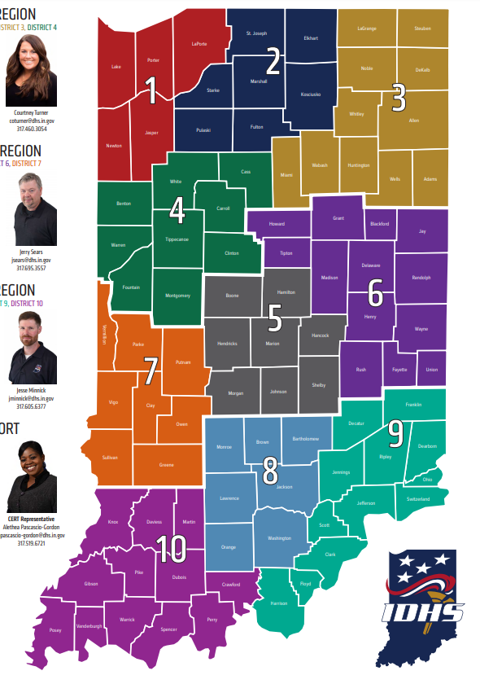

FAYETTE COUNTY

CITY OF CONNERSVILLE

## SITUATION

Fayette County is in east-central Indiana and is situated approximately 65 miles east of the capital city of Indianapolis. According to the 2023 US Census population estimates, the county covers 215 square miles and had a population of 23,362. The City of Connersville is the county seat and the largest incorporated community in the county, containing approximately 57% of the population in 2020. Figure 2 displays a general map of Fayette County and its incorporated communities while the Fayette County townships and their respective incorporated communities are outlined in Table 5.

Figure 2 

Table 5. Fayette County Townships and Incorporated Communities (MHMP)

|  |  |
| --- | --- |
| **Township** | **Township** |
| Columbia | Posey |
| Connersville | Waterloo |
| Fairview |  |
| Harrison |  |
| Jackson |  |
| Jennings |  |
| Orange |  |

The Fayette County Department of Homeland Security and Emergency Management conducts emergency preparedness awareness campaigns through various avenues of communications. Awareness campaigns include fire, severe weather, flood, tornado, cybersecurity and mitigation campaigns for children and adults. Fayette County Department of Homeland Security and Emergency Management also utilizes a variety of social networking venues, interpreters, and broadcasting methods, such as Meta/Facebook, Next Door, and the local newspaper, to ensure that diverse populations are appropriately advised.

## HAZARD AND THREAT SUMMARY

**Fayette County** is vulnerable to the effects of natural, human-caused, and technological hazards. Hazardsare defined as a source of potential danger or adverse conditions. Each hazard has an expected frequency, or probability, which is simply a calculation of how likely it is to occur in a given time, such as a year. Part of the hazard analysis is based on the worst-case scenario for hazards and their effects. Fayette County is exposed to many threats and hazards which have the potential of causing casualties, damaging, or destroying public or private property and disrupting the state’s economy. Specific characteristics, such as population distribution, land development, weather patterns and topography all promote unique challenges for managing emergencies and disasters. In any crisis or emergency, Fayette County’s foremost concern is for the protection of human life and property.

TABLE 2. Fayette County’s TOP THREATS AND HAZARDS

|  |
| --- |
| Fayette County TOP THREATS AND HAZARDS INCLUDE: |
| Hazardous Material Release |
| Communications Failure |
| Electric Power Failure |
| Animal Disease Outbreak |
| Domestic Terrorism (including active shooter) |
| Tornado |
| Flash Flood |
| Large Fire Incident |
| Winter Storms (including Ice Storms) |

The Fayette County Multi-Hazard Mitigation Plan seeks to examine the disasters that have impacted the county, identified high-risk areas of vulnerability, and explored the emerging threats. developed to guide the county in a risk-based approach to preventing, protecting against, responding to, and recovering from disasters that may threaten the county’s citizens, infrastructure, and economy. It documents historical disasters, assesses probabilistic disasters through Hazus-MH and GIS analyses, and addresses specific strategies to mitigate the potential impacts of these disasters.

TABLE 3. HAZARD AND THREAT CATEGORIES

|  |  |  |  |  |  |  |
| --- | --- | --- | --- | --- | --- | --- |
| **NATURAL HAZARDS** | | | | | | |
| **BIOLOGICAL** | **GEOPHYSICAL** | **HYDROLOGICAL** | | **METEOROLOGICAL** | | **CLIMATOLOGICAL** |
| * Human Disease Outbreak / Epidemic * Viral Infectious Diseases * Parasitic Infectious Disease * Insect Infestation * Animal Stampede * Invasive Species | * Earthquake * Mass Movement (Dry) * Rockfall * Landslide * Avalanche * Subsidence | * Flood * General Flood * Flash Flood * Storm Surge * Seiche * Mass Movement (Wet) * Rockfall * Landslide * Subsidence * Sinkhole | | * Storm * Lightning * Tropical Cyclone * Extra-Tropical Cyclone * Tornado   Solar Flares | | * Extreme Temperature * Heat Wave * Cold Wave * Extreme Winter Weather * Blizzard * Derechos * Drought * Wildfire * Land Fire * Climate Change |
| **HYDRO-METEOROLOGICAL** | | | | |
|  |  |  | | | | |
| **HUMAN-CAUSED HAZARDS** | | | | | | |
| **UNINTENTIONAL** | | **INTENTIONAL** | | | | |
| * Chemical Spill * * Hazardous Spill * * Fire * * Explosion * * Structural Collapse * System Error Yielding Failure | | * Active Shooter * Armed Assault * Biological Attack * * Chemical Attack * * Civil Unrest / Disobedience * Cyber-Attack | | | * Electro Magnetic Pulse (EMP) * * Explosives Attack * * Improvised Nuclear Attack * * Nuclear Terrorist Attack * * Radiological Attack * * Violent Extremists | |
| *= **Also, a Technological Hazard** | |  | | |  | |
| **TECHNOLOGICAL HAZARDS** | | | | | | |
| **UNINTENTIONAL OR INTENTIONAL** | | | | | | |
| * Biological Attack * Chemical Attack * Dam Failure * Electro Magnetic Pulse (EMP) * Fire * Hazardous Material Release * Improvised Nuclear Attack * Industrial Accident | | | * Mine Accident * Nuclear Terrorist Attack * Pipeline Explosion * Radiological Release * Train Derailment * Transportation Accident * Urban Conflagration * Utility Disruption | | | |

## HAZARD IDENTIFICATION AND RISK ASSESSMENT (HIRA)

There are several plans and preparedness assessments **Fayette County** uses to identify and evaluate local threats, hazards, risks, capabilities, and gaps. The Hazard Identification Risk Assessment (HIRA) is a quantitative process that addresses hazards, threats, and risks. The intent of the HIRA is to provide an overview of the countywide threat environment and to identify, analyze and quantify each hazard or threat.

All natural, human-made, or technological hazards or threats that present the greatest risk are measured using a Calculated Probability Risk Index (CPRI) formula that measures the probability, magnitude or severity, warning time and duration of the known hazard or threat. The results of the HIRA established the Threat and Hazard Identification and Risk Assessment (THIRA), step 1.

## CAPABILITY ASSESSMENTS

The National Preparedness Goal (NPG) identifies 32 core capabilities that are essential for the execution of the 5 mission areas of prevention, protection, mitigation, response, and recovery. Table 4 provides a detailed list of each of the capabilities based on five mission areas. It is important to note there are several cross-cutting core capabilities including planning, public information and warning, operational coordination, infrastructure systems, intelligence and information sharing, interdiction and disruption and screening, search and detection as outlined in the table.

The most probable hazards and threats identified in the HIRA are used to develop scenarios for the Threat and Hazard Identification and Risk Assessment (THIRA) and Stakeholder Preparedness Review (SPR). The THIRA/SPR is an interconnected process that assists communities to further evaluate their preparedness. THIRA was developed to help communities assess their risk and set capability targets that reflect their preparedness goals.

Data from the THIRA is used as the foundation for the SPR which is an outcome-based assessment that guides a comparison of capability targets established in the THIRA through an assessment of current capabilities. Communities identify and quantify gaps between current capabilities and capability targets and then identify the relation of the gap to any of the five following areas: Planning, Organization, Equipment, Training and Exercises (POETE). Finally, priority and confidence levels are determined as is plan of action and timeline for closing gaps,

This produces actionable data, providing direction on where the county needs to focus efforts and resources to have the biggest impact on achieving specific preparedness goals and addressing the impacts of their most challenging threats and hazards. See Table 5 which identifies example threats and hazard that present the greatest challenge to associated core capabilities.

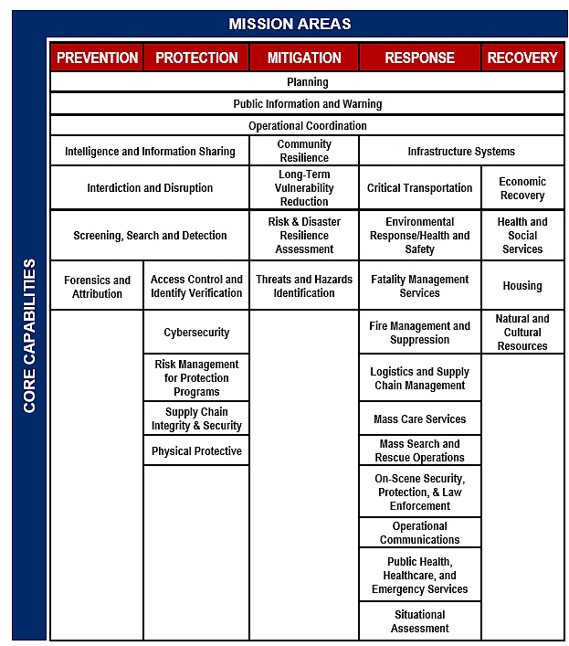TABLE 4. MISSION AREAS AND CORE CAPABILITIES

TABLE 5. HAZARDS AND CORE CAPABILITIES MOST CHALLENGED - EXAMPLE

|  |  |  |  |  |
| --- | --- | --- | --- | --- |
| **THREAT OR HAZARD THAT PRESENTS THE GREATEST CHALLENGE**  **TO EACH CORE CAPABILITY** | | | | |
| **EARTHQUAKE** | **CYBER-ATTACK** | **FLOOD** | **ACTIVE SHOOTER** | **CHEMICAL RELEASE** |
| **Operational Coordination** | **Intelligence & Information Sharing** | **Public Information & Warning** | **Interdiction & Disruption** | **Access Control & Identify Validation** |
| **Risk Management for Protection Programs** | **Forensics & Attribution** | **Logistics & Supply Chain Management** | **Screening, Search & Detection** | **Physical Protective Measures** |
| **Risk & Disaster Resilience Assessment** | **Cybersecurity** | **Supply Chain Integrity & Security** | **Threats & Hazard Identification** | **Long-term Vulnerability Reduction** |
| **Critical Transportation** |  | **Community Resilience** | **On-Scene Security, Protection & Law Enforcement** | **Environmental Response/Health & Safety** |
| **Fatality Management** | **Operational Communication** | **Public Health, Healthcare, EMS** |
| **Fire Management & Suppression** | **Mass Care Services** |  | **Situational Assessment** |
| **Infrastructure Systems** | **Planning** | **Health & Social Services** |
| **Natural and Cultural Resources** | **Economic Recovery** |
| **Housing** |
| **NOTE: A SINGLE THREAT OR HAZARD MAY CHALLENGE *MULTIPLE* CORE CAPABILITIES** | | | | |

One or more of the threats and hazards listed in Table 2 could cause cascading events which are very likely in times of disaster. The impact of those could also create the following:

* Loss of water distribution, wastewater, and water treatment capabilities
* Impassable road networks
* Need for mass care and/or feeding operations (short and long term), or sheltering, including individuals with access and functional needs, companion animals and pets
* Damage or destruction of communications networks
* Dramatic increase in media attention necessitating public information
* Overwhelming of local resources and the need for federal or state assistance
* Controlled access and re-entry control into damaged areas
* Need for damage assessment
* Increased demands and potential failure of auxiliary power for essential facilities
* Management of donated goods and spontaneous volunteers
* Contamination of public and private wells
* Depletion of staff
* Damage or destruction of vital facilities
* Reconstruction management program
* Severe economic impact
* Environmental impact on wildlife and natural environment
* Need for debris clearance, removal, and disposal
* Need for temporary debris burn sites, chipping, and mulching sites
* Damage or destruction of vital records and historical properties
* Demand for temporary housing units
* Medical emergency facilities at capacity
* Failure of 9-1-1 System
* Continuity of Operations implementation for key governmental and emergency facilities
* Looting
* Mass Casualties

## NATIONAL PREPAREDNESS SYSTEM CROSSWALK

Our nation faces a wide range of threats and hazards, including acts of terrorism, cyber-attacks, pandemics, and catastrophic natural disasters. The County, our public and private stakeholders, state, and federal partners can address the risks these threats and hazards pose by working together using a systematic approach that builds on proven preparedness activities. The National Preparedness System builds on these activities and enables the nation to meet the National Preparedness Goal.

The County equally follows the methodology of the National Response Framework (NRF), which is a guide to how the nation responds to all types of disasters and emergencies. It is built on scalable, flexible, and adaptable concepts identified in the National Incident Management System (NIMS) to align key roles and responsibilities.

The NRF is structured to help develop whole community plans and integrate continuity plans. In addition, the NRF builds capabilities to respond to cascading failures among businesses, supply chains and infrastructure sector and collaborate to stabilize community lifelines and restore services.

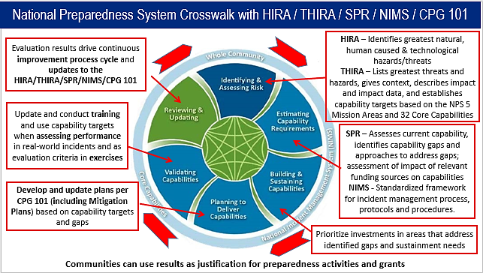**FIGURE 4. NATIONAL PREPAREDNESS SYSTEM CROSSWALK**

## WHOLE COMMUNITY PLANNING AND ENGAGEMENT

A Whole Community planning approach engages private and nonprofit sectors, including businesses, faith-based and disability organizations, and the general public, in conjunction with the participation of local, tribal, state, territorial and Federal governmental partners. The whole community has a role in risk reduction, by recognizing, understanding, communicating, and planning for a community’s future resilience to provide an agile, flexible, and accessible delivery of the core capabilities. Residents, emergency management practitioners, organizational and community leaders and government officials can collectively understand and assess the needs of their respective communities and determine the best ways to organize and strengthen their assets, capacities, and interests. Using a strategic Whole Community approach leverages the knowledge and experiences of all individuals in a community when preparing for, protecting against, responding to, and recovering from emergencies.

## PLANNING ASSUMPTIONS

For successful preparedness and response operations to take place, the following key assumptions are listed to gauge participation and support provided by Fayette County stakeholders and those at the state and federal levels:

* In the event of a disaster or emergency, Fayette County government will continue to function and provide emergency and essential services.
* Periodically, disasters, emergencies, and events will occur within the County requiring mobilization and reallocation of County resources.
* All incidents begin and end locally and are typically managed at the lowest geographic, organizational, and jurisdictional level. However, citizens have a personal responsibility to be prepared for the different types of disasters that can occur in their area.
* Government at all levels must continue to function under all threats, emergencies, and disaster conditions.
* Residents and communities will compete for scarce resources, and widespread power and communications outages may require the use of alternate methods of providing public information and delivering.
* The occurrence of one or more significant incident will result in a catastrophic situation that could overwhelm local and state resources and disrupt government functions.
* The County will be prepared to carry out emergency response and recovery operations utilizing local resources unless the magnitude of the incident exceeds the capability of County service delivery.
* Some emergencies or disasters will occur with little or no advance warning, not allowing sufficient time for appropriate emergency notifications to be sent to residents.
* A given disaster situation may require an evacuation of residents from the immediate area to protect them from further injury or death. A full-scale evacuation of a community is **not** likely. Rather, the residents living in the affected portion of that community will likely be moved. To maintain order, residents should be evacuated in accordance with this plan. Any departure from this plan will be done only at the direction of the County Commission. However, in the event of a large-scale evacuation/relocation of citizens, such efforts will be under the direction on the County Commissioners and the policy group.
* Outside assistance will be available through mutual aid agreements with nearby jurisdictions, through the District 6 EMA Coalition Mutual-Aid Agreement and through non-formal mutual aid agreements with Wayne, Rush, Union and Franklin Counties.However, it is likely that outside assistance will not be available for at least 72 hours after the onset of the disaster, emergency, or event.
* County residents, businesses, and industry will use their own resources and be self-sufficient for at least 72 hours following a significant disaster or event.
* County/local businesses and industry should have internal standard operating procedures for emergency operations including a Continuity of Operations Plan (COOP) that provides for a line of succession for senior management and a means of internal communication.
* The effects of a disaster, emergency, or event will extend beyond County boundaries in which case many other areas of the county will experience casualties, property loss, and disruption of normal life support systems.
* Fayette County to varying degrees, has capabilities, plans and procedures to provide for the safety and welfare of citizens during times of emergency and will deploy resources in a timely fashion to the extent of their capabilities.
* Fayette County will have fully committed resources or have a unique need prior to the initiation of all requests for state aid. This does not require actual exhaustion of all resources, but it does anticipate full mobilization and commitment to the emergency.
* During adeclared emergency, the County Emergency Operations Center (EOC) functions as the central coordination point for the for the direction and control of response efforts during disasters or emergencies and be the coordinating point with the State Emergency Operations Center (SEOC).THE County EOC is located on the second floor of the Fayette County Government Center Annex at 111 W. 4th Street, Connersville, IN 47331
* If the situation in the Countywarrants support from the state, the Governor may declare a state of emergency and the State Emergency Operations Center (SEOC) will be activated at the appropriate level to support a coordinated response and can send trained Incident Management Assistance Team (IMAT) members at the County’s request.
* In the event of an evacuation, the majority of the evacuees will utilize their own transportation resources. Additionally, those with pets, companion or service animals will transport their own pets and animals. Those with livestock or other farm animals will take appropriate measures to safeguard the animals via sheltering or evacuation as appropriate.
* Emergency shelters will be activated by the County Emergency Management Director (or designee). Shelters will be operated by Volunteer Organizations Active in Disasters (VOAD) such as the American Red Cross. Shelter operators will provide basic necessities including food, clothing, lodging, basic medical care, and maintain a registration of those housed in the shelter.
* Critical facilities such as hospitals and extended care facilities should have some level of emergency power and alternate energy sources available to accommodate for situations involving the loss of commercial power or other energy sources.
* NIMS is the basis for all incident management. Therefore, incident management activities shall be initiated and conducted using the NIMS Command and Management principles. In accordance with NIMS requirements, the Incident Command System (ICS) will be used as the on-scene management system, with a modified version for management of theCounty Emergency Operations Center to include the incorporation of Community Lifelines**.**
* The County has adopted an Incident Command (IC), Area Command (AC) or Unified Command (UC) structure for incident management. Area Command may be established at the County EOC. IC, AC or UC staff will work collaboratively with the County EOC to ensure a common operating picture and coordinated response.
* Fayette County complies with federal civil rights laws in the FEMA Guide “Accommodating Individuals with Disabilities in the Provision of Disaster Mass Care, Housing and Human Services” requiring equal access for and prohibiting discrimination against, people with disabilities in all aspects of emergency planning, response, and recovery.
* Approximately **22.2** percent of the Countypopulation has a disability or functional need. Planning will enable people with access and functional needs to evacuate, use emergency transportation, stay in shelters, and participate in emergency disaster related programs with their service animals.
* Incidents mean an occurrence or event (natural, technological, or human-caused), that requires a response to protect life, property, or the environment. Examples include terrorist attacks, civil unrest, wild land and urban fires, floods, hazardous materials spills, pandemics, aircraft accidents, earthquakes, tornadoes, severe thunderstorms.
* Disasters may occur at any time and may cause varying degrees of damage, human suffering, injury, death, property damage and economic hardship to individuals and private businesses, local government, and state government.
* State agencies have emergency resources and expertise available, which can be utilized to relieve emergency or disaster related problems that are beyond the capabilities of Fayette Countygovernment.
* If an incident exceeds the capabilities of both local and state governments, the state will request assistance from other states using the Emergency Management Assistance Compact (EMAC).
* Private and volunteer organizations may provide immediate life sustaining relief to individuals and families when such relief is not normally available from county government resources.
* Subject to the appropriate local and state declarations, the federal government may provide funds and assistance to jurisdictions in Indiana. Federal assistance will be requested when disaster relief requirements exceed Indiana’s capability.
* Planning, training, exercise and evaluation of essential agencies and departments will be an ongoing priority to ensure the effective use of resources and capabilities for response.
* Incidents may attract a sizeable influx of spontaneous volunteers, donations, and supplies with limited storage capacity.
* It is prudent and necessary for the county, municipalities, public safety departments, and supporting agencies to plan for and to carry out emergency and disaster response, and short- term recovery operations utilizing local resources.
* Officials of the county and all partners are aware of the possible occurrence of an emergency or major disaster and their responsibilities in execution of this plan and will respond as needed.
* All levels of government and its partners must develop Continuity of Operations planning encompassing staffing, lines of succession, and mode of operations.

## P1058#y1CONTINUITY PLANNING

Continuity planning ensures the preservation of all levels of government and continuing performance of essential functions under all emergency conditions. The composition of the Fayette CountyContinuity Plan is developed in accordance with federal continuity of operations guidelines. These provisions for the continuity of government and the continuity of operations assure critical emergency functions can be performed when elected or appointed leadership are unable to fulfill their duties and responsibilities.

Continued operation or restoration of the following facilities and systems is essential to support an immediate response following a disaster or emergency, and for long-term recovery operations:

* Health and medical facilities
* Emergency services facilities
* Communications networks
* Electrical distribution systems
* Water distribution systems
* Transportation infrastructure, resources, and facilities
* Sewer systems
* Public buildings and schools
* Landfill and debris sites
* Public and private supply centers and retail outlets

## Continuity of Government (COG)

There are a number of events or situations that could occur that would result in major disruption of government services. This could be due to an attack of some nature, cybersecurity attack, natural disaster, fire, etc. Personnel may not be available, offices may not be able to be occupied, or data may not be retrievable. Because this possibility, it is found and declared necessary to provide for additional officers who can exercise the powers and discharge the duties of Commissioner or other elected official, institute measures to protect data, and provide alternative locations to conduct business. It is prudent to provide for emergency interim succession for local governmental offices of this County and its political subdivisions in the event the incumbents thereof are unable to discharge the duties of their offices and/or are unavailable to perform the functions and duties of such office.

The Fayette Countylocal executive is responsible for establishing a line of succession to ensure the continuation of county government functions and services. This line of succession is the first step in developing a continuity of government plan and delegating authority for the successors, establishes provisions for the preservation of records, develops procedures for the relocation of essential departments and develops procedures to deploy essential personnel, equipment, and supplies. Fayette County lines of succession and authorities are established under local ordinance.

## logistics responsibilities to continuity plan activation

* Office Space: County facilities and personnel are responsible to set up office spaces for all needed staff. This includes providing temporary cubicles, tables, chairs, etc.
* Technology: Information systems personnel are responsible for providing telephones and telephone access, computers, printers, fax machines, data, etc.
* Office Supplies: Fayette County Auditor and City of Connersville Clerk Treasurer is responsible for providing all office type materials.
* Security: Fayette County Sheriff’s Department/Connersville Police Department personnel are responsible for all security operations.

## Continuity of Operations plan (COOP)

Fayette Countyhas developed continuity of operations plans for each county office to ensure its essential functions are performed during any emergency or situation which may significantly disrupt normal operations, including vital county government functions, essential responsibilities, and planning for the incapacitation of executive leadership.

# **CONCEPT OF OPERATIONS**

## GENERAL CONCEPT

This plan is based on the premise that all disasters or emergencies start and end locally. Unless specifically delegated**,** Fayette County retains Incident Command throughout the disaster or emergency. When requested by local government, the State provides state-level support and coordination to the local jurisdiction, to include situational awareness and resource mobilization. Fayette County has access to resources including emergency management and homeland security agencies, police, fire and health department, incident management teams, and specialized teams. The Indiana National Guard and other state resources may also be available, if requested through the State Emergency Operations Center (SEOC). The role of the State of Indiana during emergency response is to supplement local efforts before, during and after a disaster or emergency. If the state anticipates that its needs may exceed its resources, the governor can request assistance from other states through an Emergency Management Assistance Compact and/or from the federal government.

## COUNTY OPERATIONAL PRIORITIES DURING RESPONSE AND RECOVERY

1. Life, safety, and health

2. Property protection

3. Environmental protection

4. Restoration of essential utilities

5. Restoration of essential program functions

6. Coordination among appropriate stakeholders

## PLAN ACTIVATION AUTHORITY

The full activation of the Fayette County Emergency Operations Plan (EOP) begins with the activation of the Base Plan. The activation of the Base Plan establishes the emergency operations framework and structure needed to deliver coordinated emergency support to local governments. The activation of this framework and structure provides the basis for activating the Fayette County Emergency Operations Center (EOC).

The following individuals have the authority to activate the EOP and/or the Local EOC:

* Fayette County Commissioner President, Dale Strong
* City of Connersville Mayor, Chad Frank
* Department of Homeland Security & Emergency Management Director, Wade Walling
* Fire Chief, Scott Jones, Chad Ripberger, Chad Gronning, and Dale Munson
* Fayette County EMS Chief, Clint Hardin

In most cases, the decision to activate will be made by the collaboration among Fayette County Public Safety Leadership.

The following are consideration triggers for activating the County EOC:

* An incident has occurred that has the potential for rapid escalation.
* The emergency will be of a long duration and requires sustained coordination.
* Major policy decisions may be required.
* The volume of county requests for assistance is increasing and expected to continue.
* Pre-deployment of state or federal assets is occurring in anticipation of the emergency.
* Managing the situation requires urgent, high-level, non-routine coordination among multiple jurisdictions, state departments or other external agencies.
* The Department of Homeland Security & Emergency Management Directorshall communicate and collaborate with other response/support agencies and integrate their response plans into the overall response.
* Activation of the Fayette CountyEOC will be advantageous to the successful management of the event.

## EMERGENCY DECLARATION PROCESS

When a weather or other severe incident occurs, the following steps are followed:

* Fayette County emergency and public works personnel, private sector organizations and other private interest groups provide emergency assistance required to meet immediate human needs and restore essential services vital to public health and safety.
* Preliminary damage and impact information is gathered by Fayette County government and emergency officials and conveyed to the Indiana Department of Homeland Security (IDHS). IDHS will work with Fayette County and/or regional Private Sector organizations through the Emergency Support Functions (ESF) for updates on the impacted area.
* If necessary, the Governor declares a state of emergency, which activates the state's emergency plan to address individual and public needs as required, including the use of all state agencies’ resources and the National Guard's military resources.

#### GOVERNOR’S DECLARATION OF A STATE OF DISASTER EMERGENCY

Pursuant to Indiana Code 10-14-3-12, the Governor may declare a disaster emergency by proclamation or executive order when local response capabilities are overwhelmed. The governor’s declaration of a state level disaster emergency is *required* in order for the Governor to request a Presidential major disaster declaration as referenced in # 9 below.

## **SEQUENCE OF EVENTS**

1. Disaster event occurs.
2. Notifications are made to appropriate response agencies, disciplines and/or personnel and officials including the Department of Homeland Security & Emergency Management Director.
3. Personnel respond as appropriate based on the type of incident and assess the situation and report back to the Department of Homeland Security & Emergency Management Director.
4. The Department of Homeland Security & Emergency Management Director notifies the State Emergency Operations Center of the incident and if needed, requests assistance.
5. The County EOP and County EOC are activated to the extent necessary in accordance with the severity of the incident.
6. If deemed necessary, the State Emergency Operations Center activates.
7. Local Disaster Emergency is declared by local government officials.
8. State Emergency Operations Plan is implemented.
9. State government responds, as necessary.
10. If necessary, the Governor declares a state of disaster emergency and invokes the state’s emergency plan to augment the response to individual and public needs as required, including the use of the National Guard’s military resources.
11. Local Preliminary Damage Assessment(s) (PDAs) are conducted and analyzed.
12. If PDAs show that damage meets certain thresholds, the State requests Joint.

Preliminary Damage Assessment (JPDA) by Federal, State and Local officials.

1. Based upon the results of the Joint Preliminary Damage Assessment (JPDA), the Governor may request Federal Assistance from the President of the United States through the Federal Emergency Management Agency (FEMA)
2. If the JPDA indicates that assistance through a presidential disaster declaration is not likely, the State may still request a disaster declaration from the United States Small Business Administration and utilize the State Disaster Relief Fund (Individual and/or Public Assistance Programs) to aid Hoosiers in need.

**NOTE:** The ability to gather damage information may be hindered and delayed due to the nature and severity of the disaster. These delays may also extend the amount of time it takes to determine whether the State is eligible to request a major disaster declaration from the President of the United States.

## COUNTY BOARD AND COMMISSION COORDINATION

Department of Homeland Security & Emergency Management actively works with multiple boards and commissions to achieve and maintain high standards in various areas of public safety such as building safety, emergency services, emergency management and school safety. The boards and commissions include:

* Fayette County Commissioners
* Fayette County Council
* City of Connersville Mayors Office
* Connersville City Council

## INCLUSION, ACCESS, AND FUNCTIONAL NEEDS

Fayette County works with public, private, and non-profit organizations to build a culture of preparedness and readiness for emergencies and disasters that goes beyond meeting the legal requisites of people with disabilities as defined by the most current version of the [Americans with Disabilities Act (ADA)](https://www.ada.gov/)or for individuals with access and functional needs.

Fayette County integrates the Federal Emergency Management Agency’s (FEMA)’s access and functional needs guidance, which identifies an individual’s actual needs during an emergency rather than negatively labeling them as “handicapped,” “crippled,” or “abnormal.”

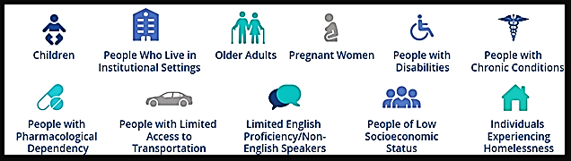This guidance is inclusive as it also includes people with temporary needs or those who do not identify themselves as having a disability. This includes women who are pregnant, children, older adults, individuals with limited English communication, people with limited transportation access and those with household pets and service animals.

Inclusion of access and functional needs during all phases of planning for response and recovery actions including evacuation, sheltering, emergency notification and public assistance, is more specific in nature than what the EOP base plan identifies. Therefore, detailed information is outlined in those support plans and annexes.

Additional awareness which helps ensure inclusive emergency preparedness planning include addressing the needs of children and adults in areas such as:

**SELF-DETERMINATION** – Individuals with access and functional needs are the most knowledgeable about their own needs.

**NO “ONE-SIZE-FITS-ALL”** – Individuals do not all require the same assistance and do not all have the same needs.

Preparations will be made for people with a variety of functional needs, including women that are pregnant or nursing, as well as people who use mobility aids, require medication or portable medical equipment, use service animals, need information in alternate formats, rely on a caregiver, or have food needs.

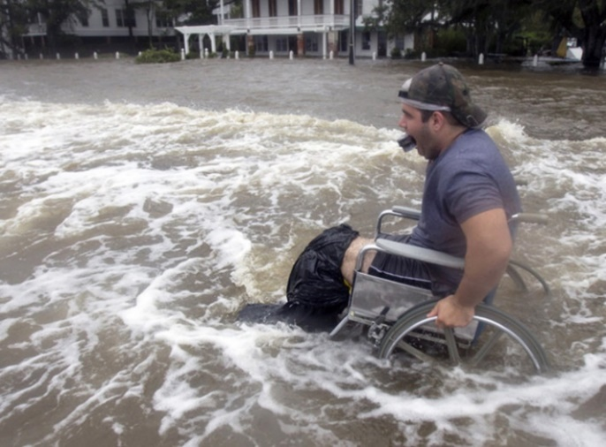During risk assessments, it is imperative to identify all capability and capacity gaps and actively develop plans to reduce or close those gaps

**EQUAL OPPORTUNITY, INCLUSION, INTEGRATION AND PHYSICAL ACCESS** – All individuals must have the same opportunities to benefit from emergency programs, services, and activities. These must be provided in an integrated setting that all people can access. This includes notification of emergencies, evacuation, transportation, communication, shelter, distribution of supplies, food, first aid, medical care, housing, application, and benefits.

**NO CHARGE** – Individuals with access and functional needs may not be charged to cover the costs of measures necessary to ensure equal access and nondiscriminatory treatment.

**EFFECTIVE COMMUNICATION** – Individuals must be given information that is comparable in content and detail to that given to the public. It must also be accessible, understandable, and timely.

Auxiliary aids and services may be needed to ensure effective communication. These resources may include pen and paper; sign language interpreters on-site or through video; and interpretation aids for people who are Deaf, Deaf-blind, hard of hearing or may need large print information.



**PROGRAM MODIFICATIONS** – Individuals must have equal access to emergency programs and services, which may entail modifications to rules, policies, practices, and procedures. Service staff may need to change the way questions are asked, provide reader assistance to complete forms, or provide aid in a more accessible location.

The EOP planning process includes the use of whole community guidance while developing emergency plans to ensure access and functional needs are identified for needed modifications.

**NOTE** See the FAYETTE COUNTY-PUBLIC HEALTH EMERGENCY OPERATIONS PLAN MAY 2023.

# ORGANIZATION AND ASSIGNMENT OF RESPONSIBILITIES

## ORGANIZATION

Effective organization and coordination are critical regarding mitigation, preparedness, response and recovery planning and actions for emergencies and disasters. Entities with primary and support roles in emergency management responsibilities must be immediately available and committed to fulfilling their assigned roles and responsibilities to assist Fayette Countyand meet the needs of our county residents. This section tasks departments of Fayette County, municipalities, quasi-government agencies, and volunteer agencies, with specific emergency functions that may be in addition to their day-to-day responsibilities. Each agency listed is responsible for the development and maintenance of internal SOP’s, SOG’s, checklists, and/or memorandums of understanding in order to accomplish these responsibilities.

Each agency is responsible for ensuring representation in the EOC if requested.

## ASSIGNMENT OF RESPONSIBILITIES

#### Chairperson, County Board of Commissioners

* Fayette County Commissioner President Serves as the Chair of the Fayette County Policy Group.
* Fayette County Department of Homeland Security and Emergency Management Directorcarries out provisions of County statutes and local ordinances relating to emergencies.
* Fayette County Commissioner President and Department of Homeland Security and Emergency Management Director can declare a State of Emergency for Fayette County and assume direction and control of emergency operations in cooperation with other members of the control group, which may, but all are not required, include the following:
  + Activation of the County Emergency Operations Plan.
  + Order an evacuation to include all or portions of the county.
  + Restrict the sale of alcohol and or firearms.
  + Order a curfew.
  + Restrict entry into County.
  + Enforce ordinances in effect.
  + Ensure adequate planning for Hazardous Materials events.
  + Ensure the line of succession for county departments and agencies.
  + Relocate the seat of government if administrative offices become damaged beyond usage.
  + Declare a State of Emergency in existence for unincorporated areas of the county, if necessary and where applicable, in coordination with municipal officials.
  + Implement other measures to protect life and property.
  + Coordinate emergency response activities with Chairpersons of adjoining jurisdictions and Mayors in Fayette and surrounding Counties.
  + Direct county personnel to return to work following a disaster or emergency.

### Fayette County **ADVISORY COUNCIL**

The Fayette County Emergency Management Advisory Council includes the following members:

* Fayette County Board of Commissioner’s President or designee,
* Fayette CountyCouncil President or designee,
* City of Connersvill**e** Mayor or designee
* Member of Fayette County’s Township Trustees or designee,
* Fayette County Sheriff.

## **COUNTY EMERGENCY OPERATIONS CENTER**

The County Emergency Operations Center (EOC) is the physical location from which response and recovery activities are coordinated during a major emergency or disaster. The EOC is managed by the Department of Homeland Security & Emergency Management Director. The key function of the EOC is to ensure that first responders working in the field and at the scene have the resources (i.e., personnel, tools, and equipment) needed to carry out their assignments.

EOCs help form a common operating picture of the incident and relieve on-scene command of the burden of external coordination and securing and delivery of additional resources. The core functions of an EOC include direction and control, coordination, communication, priority setting, resource management and tracking, information and data collection, analysis, and public information dissemination. It allows key decision-makers to operate in one place to coordinate and communicate with support staff. The EOC can be configured to expand or contract as necessary to respond to the different levels of incidents requiring assistance.

When activated, the County EOC does not “take command” of the emergency or disaster. Tactical direction and control rests with the Incident Commander(s) in the field. The EOC does not provide on-scene incident management but can request qualified personnel to augment the Incident Management Team (IMT) through adjacent county mutual aid agreements or augmentation from the State Incident Management Assistance Team (IMAT) through a resource request to the SEOC. The EOC is also the central coordination center for 15 Emergency Support Function (ESF) subject matter experts and key organization personnel who facilitate an effective, direct, and coordinated response to the needs of the citizens in the event of a natural disaster or significant events. The EOC manages the county’s response and initial recovery operations. The EOC staff tracks and disseminates late breaking information gathered from its multiple networks of local, state, federal, private sector, volunteer organizations and emergency management agencies across the state.

The EOC is located at 111 W. 4th Street, Connersville, IN 47331. If needed, an alternate EOC will be established at the as needed location. This move to the alternate EOC will take place in phases as the situation allows.

A mobile command center vehicle is also available in late 2024 in the event that both the primary and secondary EOC sites are unavailable, and for scene operations. The EOC is capable of operation on an intermittent or continuous basis for as long as the situation requires.

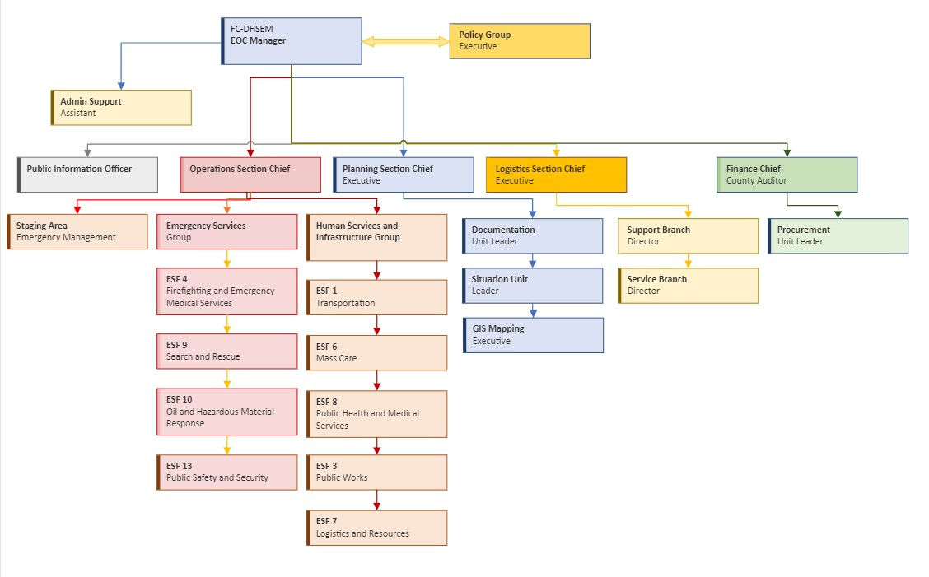

## FIGURE 5. FAYETTE COUNTY EOC HYBRID ESF/ICS ORGANIZATIONAL STRUCTURE

During large scale or multiple incidents, the County EOC prioritizes support and resources based on county requirements. If the disaster situation is of such magnitude as to require State and Federal assistance; the State, through the State Emergency Operations Center (SEOC) or a Joint Field Office (JFO), will serve as the primary coordinating agency for federal assistance.

The EOC utilizes a secured internet based common operating picture called WebEOC that has streamlined both the process of reporting information with the SEOC, as well as the process of sharing real-time information across multiple jurisdictions and levels of government. It is through collaboration and cooperation between local, State and Federal partners that ensure a timely response to all-hazard incidents, both natural and man-made.

## FAYETTE COUNTY BOARD OF COMMISSIONERS PRESIDENT

* Serves on the Fayette County Emergency Management Advisory Board
* Ensures adequate space, facilities, and equipment for an EOC
* Directs county agencies to develop and update emergency plans and SOPs to respond to emergencies and disasters
* Supports the EMADirector in annual exercises and tests of the emergency plans
* Acts as county’s PIO or designates an alternate that is trained in PIO procedures and has a support team in place
* Coordinates emergency response activities with Managers of adjoining jurisdictions
* Implements direction, control, coordination, and policy-making functions as necessary to provide for optimum protection of public health and safety
* Ensures that all county agencies document all expenditures related to the emergency/disaster in accordance with FEMA guidelines
* Determines sheltering or evacuation needs, in coordination with the EMA Director, and with the advice of other officials as appropriate
* Issues orders to terminate non-essential functions of county government and re-direct forces to respond to the disaster
* Plans for the activation of damage assessment and recovery functions of local government
* Ensures that persons who have access and functional needs have been provided assistance, if needed and as possible
* Provides financial and resource support to shelters including pet co-located shelters.
* Develops and issue policies on essential personnel prior to emergency situations
* Directs all county personnel to support emergency operations assigned, in coordination with the EOC

## PUBLIC INFORMATION OFFICER

* Maintains current inventories of public information resources and partners
* Prepares procedures, memorandums of understanding, SOPs, and mutual aid agreements to coordinate public information services during disasters.
* Develops talking points and pre-scripted messages/media briefs for significant incidents and events in conjunction with the County Commissioner President and the EMA Director.
* Coordinates, with the EMA Director’s approval, the release of all media advisories and news releases for county departments during emergency situations
* Provides for citizen information and issuance of emergency instructions
* Offers emergency information for non-English speaking and Deaf and Hard of Hearing individuals.
* Informs citizens and visitors of evacuation orders, recommended protective actions, flooded areas, impediments to movement and other hazards
* Monitors print and electronic media outlets for accuracy of information and secure correction of misleading information
* Coordinates the access of media representatives to public officials
* Handles media inquiries
* Maintains an activity and phone log
* Provides feedback to EOC staff personnel on citizens’ complaints and concerns
* Maintains up-to-date phone, fax, and email contact lists for release of information to local media contacts
* Provides a schedule for media briefings.

## COUNTY EMERGENCY MANAGEMENT DIRECTOR

* Serve as the Vice-Chair of the Fayette County Emergency Management Advisory Board
* Leads the development, maintenance, and updating of the County Emergency Operations Plan, standard operating procedures, guidelines, memorandums of understanding, implementing documents and resource manuals used during emergency operations
* Develops, in consultation with all first responder agencies county-wide criteria for the cessation of emergency services when unsafe to operate and maintain and hold calls for service until such time it is again safe to respond
* Performs assigned duties according to county general statutes and local ordinances
* Develops and maintain strategic, tactical and continuity, hazard mitigation and recovery plans in accordance with federal and state guidelines
* Conducts Threat and Hazard Identification Risk Assessments and Stakeholder Preparedness Review Reports and submit NIMS and CPG 101 compliance annually.
* Coordinates emergency operations within the county and provide emergency support services to municipalities
* Maintains current notification and recall lists of departmental personnel, as well as key officials with county and city government, public safety departments, and other response and recovery partners
* Provides for the training of personnel within the Emergency Management Agency and EOC and assist, as appropriate with the training of emergency response and recovery partners. Training to include EOC orientation, NIMS/ICS training, exercises, and other training as deemed necessary.
* Maintains and update a current list of key resources in the county, including fuel and operational personnel to support response and recovery operations
* Receives and coordinate requests for resources from municipalities and direct resources to areas of greatest need
* Coordinates with private industry for use of privately owned resources
* Coordinates emergency response activities with neighboring jurisdictions
* Forwards requests for additional resources to either adjoining jurisdictions or to the Indiana Department of Homeland Security when county resources are unable to meet response or recovery requirements
* Alerts and activate county emergency services when informed of an impending emergency or major emergencies which occur
* Serves as a member of the Local Emergency Planning Committee (LEPC) as defined by SARA Title III planning requirements
* Serves as the principal advisor to County Policy Group during emergency operations
* Identifies and arranges for suitable shelters for emergencies or disasters in coordination with the Fayette County Department of Health and the American Red Cross
* Maintains operational readiness of the EOC, access and functional needs shelters and pet co-located shelters, when required
* Ensures that adequate facilities are available for various functions as needed to support disaster operations, e.g., pre-designated Central Distribution Receiving Point, Points of Distribution, Disaster Recovery Centers, etc. with appropriate agreements in place
* Maintains administrative records as needed
* Ensures that required documentation is maintained during an emergency period
* Functions as an alternate PIO, when needed
* Ensures adequate warnings are disseminated throughout local government, emergency departments, and county
* Disseminates public information and conduct education programs relating to disaster recovery procedures, pre-disaster
* Assists with securing Disaster Recovery Center facilities and equipment
* Assists with notification of applicants that may be eligible for Public Assistance Programs
* Assists the LEPC in planning for hazardous material incidents
* Ensures that the public is educated throughout the year with public awareness programs concerning the various hazards and threats within the county, and the need to be self-sufficient for a period of seven to ten days
  + Manages public safety fixed site communications and serves as a liaison in combination with the Communications Manager
  + Reviews written plans submitted annually by various agencies and departments
* Ensures operational mobile command post
* Ensures redundant 9-1-1 facilities are regularly tested and operational as needed
* Maintains designated and identified portable generators for emergency operations
* Serves as the lead agency for disaster preparedness planning and funding
* Develops, maintain, and update SOPs for each ESF during emergencies
* Ensures that communication procedures are established for the use of logs, messages, forms, and message control
* Ensures that contracted public safety departments are instructed annually, and prior to predictable disasters on required documentation for possible reimbursement
* Leads and coordinate the damage assessment process
* Provides trained Damage Assistant Teams to assist with damage assessment

## COUNTY SHERIFF

* Serves as a member of the Fayette County Emergency Management Advisory Board
* Develops and maintain SOPs to direct and control law enforcement operations during emergencies or disasters
* Provides direction and control for law enforcement, traffic control, evacuations, and re- entry
* Identifies law enforcement assistance needs and develop necessary mutual aid agreements to support those needs
* Provides security for the EOC, staging areas, shelters, vital facilities, and essential equipment locations
* Controls ingress and egress into damaged, evacuated, and secured areas and facilities
* Directs activities as lead agency for county search and rescue activities
* Relocates and house prisoners when necessary
* Coordinates the need for additional law enforcement support with the Indiana State Police, other state law enforcement agencies, City Police Departments, and adjacent jurisdictions
* Develops procedures to ensure that county law enforcement personnel are trained in accordance with OSHA 1910.120 for hazardous material incidents
* Coordinates actions with city police departments to ensure continuity of operations throughout the county
* Safeguards staff and prisoners

## COUNTY HEALTH DEPARTMENT DIRECTOR

* Develops, maintain, and revise SOPs for emergency public health operations during emergencies
* Coordinates health care for emergency shelters and mass care facilities with Fayette County Department of Health, American Red Cross and/or the Salvation Army
* Provides nurses to staff emergency shelters
* Coordinates with water supply authorities to expedite emergency public water supplies
* Provides health inspections and immunizations to evaluate, detect, prevent, or control communicable disease
* Coordinates environmental public health activities for waste disposal, refuse, food safety, water, sanitation, restaurants, and vector/vermin control in the County
* Provides inspection of mass care facilities, to assure proper sanitation practices
* Coordinates with the proper authorities to establish a temporary morgue, or if necessary, expand morgue services
* Coordinates with area mental health center to ensure that crisis counselors are available in disaster assistance centers, shelter area, crisis line activities and for support staff
* Coordinates the distribution of exposure limiting drugs, medicines, vaccines, or other preventative measures when required
* Coordinates animal control service and facilities and to prepare for and staff pet co- located shelters in cooperation with County EMA Director.
* Provides support for individuals with access and functional needs occupying shelters during an emergency, as needed
* Provides water testing services
* Serves as the lead agency for animal control issues
* Coordinates the efforts of other animal welfare groups and volunteers during times of disasters
* Identifies property that could be used to house large animals forced from their regular quarters
* Coordinates emergency vaccination for rabies as required
* Coordinates efforts to re-unite lost pets and owners and outside volunteer agencies
* Advises the EOC, other county, and municipal staff on animal protection issues

## COUNTY AUDITOR

* Develops, maintain, and revise SOPs for county tax operation and record protection during significant incidents or events
* Provides property tax information assistance for county residents
* Revises property tax records to reflect damage to privately owned property as directed
* Provides clerical and support staff if needed
* Provides GIS information and support as needed

### **Superintendent**, Fayette County Public School System

* Serve as a member of the Fayette County Emergency Management Advisory Board
* Develops, maintain, and revise SOPs for the safety and protection of students, facility, and other personnel during emergency situations
* Coordinates evacuation and transportation operations for students during emergencies
* Provides support personnel, equipment, and facilities as necessary (schools, buses, bus drivers, cafeteria personnel, and other equipment, etc.)
* Provides school facilities for temporary shelters, as needed, and develop memorandum of understanding for use of facilities
* Assists with transportation of county residents in a disaster or emergency situation including the elderly, handicapped and medically fragile citizens when requested by the EOC
* Maintains school transportation resources and provide for the refueling of these resources when necessary
* Following an incident or disaster, conducts damage assessments of school properties and report to the EOC or Emergency Management Director
* Provides assistance with standby generator connections and refueling of generators where needed

## COUNTY HEALTHCARE FACILITIES

* Develops, maintains, and revises SOPs for mass casualty activities during major emergencies or disasters
* Identifies equipment, manpower limitations, and develop mutual aid agreements for the procurement of needed resources during emergencies or disasters
* Coordinates with other area hospitals concerning the receipt of mass causalities
* Coordinates, when appropriate with the County Health Director, funeral homes, medical examiners, American Red Cross liaisons, and other health care professionals
* Supports community drills and exercises whenever possible

## COUNTY EMS MEDICAL DIRECTOR

* Develops, maintains, and revises SOPs directing the provisions of emergency medical care and mass casualty activities County, to include the consideration of potential community isolation and other disaster operations
* Coordinating with and advising the EOC, the EMA Director, and all emergency medical agencies in taking actions to reduce injuries and the loss of life during disaster operations
* Support the EMA Director and emergency medical agencies in the conducting of disaster drills and exercises

## COUNTY & CITY FIRE DEPARTMENTS

* Develops and maintains standard operating procedures for the coordination of firefighting, rescue, hazardous materials response, and emergency medical activities, including operations during disasters and major emergencies
* Assists with dissemination of warning instructions as warranted
* Coordinates firefighting actions
* Provides for the relocation of firefighting equipment to diverse locations during impending disasters as needed to prevent damage
* Supports and participate in disaster drills and exercises at least annually
* Conducts basic search and rescue operations during emergency or disaster situations
* Supports the evacuation of facilities housing individuals with access and functional needs
* Provides preliminary, emergency clearing of roadways following a disaster and assisting in the provision of preliminary damage reports to the EOC
* Participates in post-disaster sub-grantee meetings and workshops when state or federal reimbursement is applicable
* Maintains detailed, complete, written documentation of all disaster related incidents, events, and work performed, such as the of ICS 214 forms
* Staffs their stations during disasters or as soon as safe to do so, particularly when communications and/or 9-1-1 services are down
* Ensures the capability exists to alert personnel on your primary assigned frequency (talk-a-round mode) in case of central communications system failure
* Serves as a community hub for the distribution of emergency public information when communications are non-functional, and a point for the provision of emergency supplies as appropriate (PODs)
* Outside of city limits, implement local command and control within your districts until attempt to contact can be made with the EOC, at which time operations should be coordinated with the EOC

#### county Information Technology (IT) Director

* Develops SOPs for the use, repair, replacement of, or restoration of county IT systems, including websites, Geographic Information System (GIS), email, and 9-1-1 data systems, social media, and WebEOC.
* Oversees management of cybersecurity protocols and backup systems
* Develops cybersecurity response plan in conjunction with EMA Director and IT staff
* Provides cybersecurity awareness training to all county employees
* Provides GIS specialists during disasters or emergencies
* Provides computers and telecommunications support staff, including around the clock support to the EOC when operational
* Provides real-time support for internet and telephone resources to county temporary field offices
* Assists with the collection and dissemination of situational awareness material
* Assists departments with vital records retention, protection, and restoration.

#### Clerk of Superior Court

* Coordinates and notifies Judicial Officials of potential impacts to the Court Systems and operations
* Coordinates court closures and re-openings as requested by the EOC or County Commissioner President
* Develops, maintain, and revise SOPs for vital record retention, protection, and restoration.

#### Mayor

* Serves as a member of the Fayette County Emergency Management Advisory Board
* Provides a 24-hour contact or representation in the EOC
* Ensures coordinated policy and public information dissemination in conjunction with the County PIO and County EMA Director.
* Utilizes municipal personnel, facilities, and equipment resources to support the County EOP, not to conflict with municipal requirements
* Assess the needs of the municipality and request resources through the County EMA Director
* Enforce provisions of local ordinances relating to disasters/emergencies as well as Indiana statutes
* Declare a State of Emergency for the municipality in cooperation with the county and other municipalities
* Ensure protection of life and property within the municipality
* Conduct damage assessment surveys utilizing municipal officials within municipal limits and provide for training of damage assessment teams on a regular basis
* Coordinate development of internal, interdepartmental, and interagency SOPs and memorandums of understanding
* Ensure that drills and emergency exercises are conducted periodically to test the EOP
* Coordinate policy making functions necessary to ensure public health and safety within the municipal borders
* Make available municipal resources, as appropriate, in response to resource requests from other agencies
* Implement emergency policies, procedures, and ordinances as appropriate for the governing body

#### Local Emergency Planning Committee (LEPC) Chairman

* Carries out the responsibilities for local emergency planning pursuant to SARA Title III and adheres to the policies of the NC Emergency Response Commission.
* Assess and make recommendations as to the current level of prevention, preparedness and response capabilities of existing programs and procedures.
* Ensure the development of plans to protect the public from hazardous substances
* Develop and ensure that procedures for notification are in place and effective in the event of a hazardous materials accident
* Ensure that facility emergency coordinators provide information to the LEPC in a timely manner

### American Red Cross (arc)

* Coordinate activities with the County EMA Director, County Social Services Director and County Health Director in providing shelter/mass care services
* Provide support personnel as requested for shelter/mass care operations
* Provide trained and physically capable shelter managers and staff to operate ARC designated shelters, if needed
* Provide training for shelter staff in support of shelter operations
* Cooperate/coordinate with Salvation Army and other agencies in the delivery of mass feeding services

#### All County Staff

* All Department Heads and their Deputies shall maintain accurate and complete recall rosters, including emergency contacts
* All county employees may be required to support incident operations to ensure an effective response and recovery to any all- hazards incident that occurs in **Fayette County**.
* As soon as safe to do so, all employees not otherwise tasked shall report to work following a disaster in accordance with instructions of the applicable Department Head, the County Commissioner, or the EOC, which may indicate an alternate work location or assignment
* In the absence of direction or communications, attempt to report to your normal work location for posted instructions or other messages.

#### EMERGENCY SUPPORT FUNCTIONS (ESF)

Each Emergency Support Function (ESF) is composed of a department or agency that has been designated as the ESF coordinator, along with a number of primary and support agencies. Primary agencies are designated on the basis of their authorities, resources, and capabilities. Support agencies are assigned based on resources or capabilities in a given functional area. To the extent possible, resources provided by the ESFs are identified consistently with NIMS resource typing categories.

As part of the role of the CountyESF agencies, each agency maintains their staffing roster and incorporates their Standard Operating Procedures (SOPs) into the ESF role.

Checklists are maintained as a part of each ESF and updated on a regular basis to maintain current protocol, documentation, and available tools. A paper copy of these checklists should be filed at the ESF workstation in the EOC along with the EOC SOPs and checklists.

ESFs have proven to be an effective way to organize and manage resources to deliver core capabilities. The Emergency Support Function (ESF) structure utilized in the County EOC reflects the emergency management structure defined in the National Response Framework (NRF). Each of the 15 ESF’s provides support, resources, program implementation and services to meet their specific challenges, roles, and responsibilities within the National Preparedness Goal mission areas of Prevention, Protection, Mitigation, Response and Recovery phases of emergency management.

### ESF #1 – TRANSPORTATION

Primary Coordinating Agency

**City of Connersville Street Department/Fayette County Highway Department**

General Functions

* County/City public road support
* Transportation safety
* Restoration/recovery of transportation infrastructure.
* Movement restrictions
* Damage and impact assessments

### ESF #2 – COMMUNICATIONS

Primary Coordinating Agency

**Fayette County 911 Central Dispatch**

General Functions

* Coordination with telecommunications and information technology industries
* Restoration and repair of communications infrastructure
* Protect, restore, and sustain county information technology resources.

### ESF #3 – PUBLIC WORKS

Primary Coordinating Agency

**City of Connersville Public Works**

General Functions

* Infrastructure protection, emergency repair and restoration
* Engineering services and construction management
* Critical infrastructure liaison

### ESF #4 – FIREFIGHTING & EMS

Primary Coordinating Agency

**City of Connersville Fire/Bentonville Fire/Everton Fire/Glenwood Fire Department, and Fayette County EMS.**

Geral Functions

* Firefighting activities support
* Task Force support
* EMS support
* Resource support to rural and urban firefighting operations

### ESF #5 – PLANNING AND EMERGENCY MANAGEMENT

Primary Coordinating Agency

**Fayette County Department of Homeland Security and Emergency Management**

General Functions

* Coordination of incident management and response efforts
* Resource and human capital
* Incident action planning

### ESF #6 – MASS CARE, HOUSING AND HUMAN SERVICES

Primary Agency

**Fayette County Department of Health/American Red Cross**

General Functions

* Mass care/shelter
* Emergency Assistance
* Disaster housing
* Human services

### ESF #7 – LOGISTICS AND RESOURCE SUPPORT

Primary Coordinating Agency

Fayette County Department of Homeland Security and Emergency Management

General Functions

* Incident Resource Support
* Identification, distribution, and management of critical resources

### ESF #8 – PUBLIC HEALTH AND MEDICAL SERVICES

Primary Agency

**Fayette County Department of Health/Fayette County EMS**

General Functions

* Public health
* Medical support
* Mental health services
* Mortuary services

### ESF #9 – SEARCH AND RESCUE

Primary Agency

City of Connersville Fire/Bentonville Fire/Everton Fire/Glenwood Fire Department/Fayette County Emergency Management IMT

General Functions

* Life-saving assistance
* Urban search and rescue operations
* Confined space rescue

### ESF #13 – LAW ENFORCEMENT

Primary Coordinating Agency

**Connersville City Police Department/Fayette County Sheriff’s Department**

General Functions

* Law enforcement and military assistance
* Security planning and technical resource assistance
* Public safety/security support/escort support
* Support to access, traffic, crowd control and evacuation

### ESF #15 – EXTERNAL AFFAIRS

Primary Coordinating Agency

Fayette County Department of Homeland Security and Emergency Management

General Functions

* Emergency public information, warnings, and pre-incident information
* Media and community relations
* Congressional and international affairs

Each ESF has a detailed Annex that is not included in the EOP Base Plan.

### Functional responsibilities

#### Incident Command

* Establish command structure
* Define perimeters
* Evacuation/sheltering-in-place
* Protection parameters for responders
* Protection parameters for civilians
* Protection parameters for property
* Incident-wide communications
* Order/obtain necessary resources
* Transportation issues
* Assess/restore critical infrastructure

#### Fire Response

* Incident/Unified Command
* Fire suppression
* Emergent medical
* Urban search and rescue
* HAZMAT
* Assist with evacuation
* WMD monitoring
* Manage fire department resources

#### Law Enforcement

* Incident/Unified Command
* Traffic control
* Perimeter control
* Security
* Evacuation
* Mobile Command Center
* Manage law enforcement resources

#### Health & Medical

* Unified Command
* Coordinate mass medical care
* Medical Supplies
* WMD/Illness monitoring/surveillance
* Temporary morgue
* Food monitoring
* Quarantine management
* Victim/patient identification

#### PUBLIC WORKS

* Unified Command
* Utilities assessment/restoration
* Debris removal
* Traffic control
* Emergency demolition
* Structural assessment

#### Communications

* EOC Procedures
* Warnings / Notifications

#### PUBLIC AFFAIRS OFFICER

* Establish a JIC
* Collect information from incident command/resources

#### SHELTERING/MASS CARE

* Establish/manage shelters
* Provide relief supplies to responders

#### Transportation

* Resources

#### Resources/Finance/Planning

* Track costs
* Track resources
* Purchase/acquire needed resources
* Planning
* Records/Declaration/Public Assistance
* Manage records
* Manage cost per site
* Properly declare “State of Emergency”
* Request State and Federal Aid

#### terrorism Preparedness

* Intelligence & Investigation
* Alert & notification
* Critical Infrastructure Protection
* Dignitary Protection
* Public information
* Demobilization
* NBC response
* Citizen corps

### MUTUAL AID (AMEND TO COUNTY protocols)

**Fayette Count District 6 Emergency Management Coalition Mutual-Aid agreement**

Even without pre-approved mutual aid agreements, the State of Indiana has enacted Indiana Code IC 10-14-3-10.8 (d) which states "A participant that is impacted by any incident, disaster, exercise, training activity, or planned event that requires additional resources may request mutual assistance or aid from any other participant. This request shall be made by the chief executive of the requesting participant to the chief executive of a provider participant. If the request is made orally, the requesting participant shall provide the provider participant with written confirmation of the request not later than seventy-two (72) hours after the oral request is made.” There are additional details in the law, which can be found at: <http://iga.in.gov/legislative/laws/2019/ic/titles/010/#10-14-3-10.8>.

#### INCIDENT COMMAND SYSTEM (ics) MANAGEMENT

ICS was designed by identifying the primary activities or functions necessary to effectively respond to incidents. Analyses of incident reports and review of military organizations were all used in ICS development. These analyses identified the primary needs of incidents.

As incidents became more complex, difficult, and expensive, the need for an organizational manager became more evident. Thus, in ICS and especially in larger incidents, the Incident Commander manages the organization and not the incident.

FIGURE 7. ICS COMMAND STAFF ORGANIZATIONAL CHART 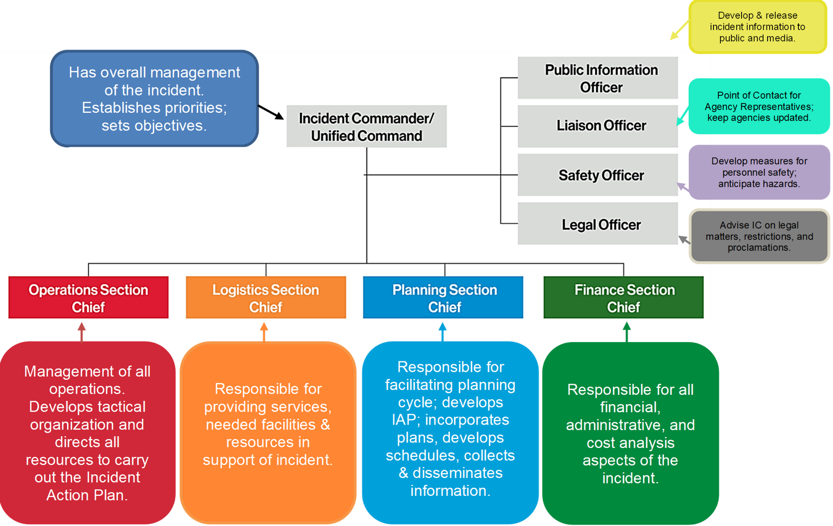

### PRIVATE SECTOR ORGANIZATIONS (AMEND TO COUNTY protocols) Not completed

The [National Infrastructure Advisory Council (NIAC)](http://www.dhs.gov/xlibrary/assets/niac/niac_critical_infrastructure_protection_assessment_final_report.pdf) reported nearly 90 percent of our nation’s critical infrastructure is owned or managed by private companies. Emergency management’s collaboration with these private sector organizations is essential for effective response and recovery efforts. Private-sector organizations provide critical specific disaster-related service to the County. Fayette County Department of Homeland Security and Emergency Management has established pre-incident operational agreements and plans in order to better coordinate resources during incidents.

### DONATIONS MANAGEMENT (AMEND TO COUNTY protocols) Not completed

The management of donations, especially unsolicited donations, is critical for an efficient and effective response to any disaster. Spontaneous, unaffiliated volunteers often arrive with unsolicited donations and well-intended individuals ship or drop off unsolicited and often unneeded items which can pile up quickly and overwhelm the response site. COAD Members can provide Donations Management services following the event as well as throughout Long-Term Recovery

### VOLUNTEER MANAGEMENT

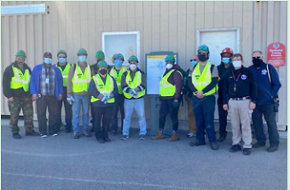The management of spontaneous volunteers is critical for an efficient and effective response to a disaster. While their intentions are good, these untrained, unannounced volunteers who show up within hours or days of an event can create havoc for the Emergency Management Agency (EMA) if not properly supervised. County COADs (Community Organizations Active in Disaster) can provide Volunteer Management for these unaffiliated volunteers and make the best use of the volunteers’ efforts. Affiliated Volunteers are trained and experienced members of COAD organizations and coordinate before deploying to respond to the immediate and long-term recovery needs of the survivors and the community.

### INDIVIDUALS AND FAMILIES

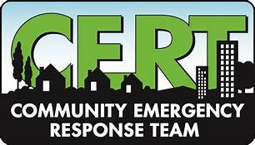Resilient communities begin with prepared individuals and families and the leadership and engagement of local government and the private sector. Individuals, families, and caregivers should enhance their awareness of risk and threats, develop family emergency plans that include care for pets and companion animals and prepare emergency supply kits. Individuals are also encouraged to volunteer in their communities and with their Community Emergency Response Team (CERT).

# DIRECTION, CONTROL AND COORDINATION

## DIRECTION AND CONTROL

The overall direction and control of county emergency activities is vested with the President of the County Commissioners or alternate within the chain of succession.

The Fayette County Department of Homeland Security and Emergency Management Director carries out the function of disaster coordination at the direction of the County Commissioners. The Incident Commander (IC) will establish on-site management. The supporting agencies and their respective responsibilities are identified in the ESFs of this plan.

In order to conduct effective emergency operations, direction and control functions will operate from the **Fayette County** **Emergency Operations Center, 111 W. 4th Street, Connersville, IN 47331**. The EOC shall be activated as necessary in accordance with EOC Standard Operating Procedures (SOPs) or upon the direction of the Chairman of the Board of Commissioners (their successor), the Fayette County Department of Homeland Security and Emergency ManagementDirector or their deputies.

## ACTIVATION OF COUNTY EMERGENCY OPERATIONS CENTER

At a minimum, the county’s EOC will be activated upon the direction of the President of the Board of Commissioners (their successor), the Fayette County Department of Homeland Security and Emergency ManagementDirector or their deputies if one or more of the following situations occur.

* Widespread, imminent threat to public safety/health
* Extensive multi-agency/jurisdictional response and coordination are required to resolve or recover from the emergency
* Any incident creating widespread evacuation
* Local resources are inadequate/depleted and significant mutual aid, state, and or federal resources are needed to resolve the emergency
* The disaster affects multiple political jurisdictions within the county, which are relying on the same emergency resources to resolve the situation
* The county EOC serves as the central direction and control point for countywide emergency response activities. Should this location become inoperable, an alternate EOC can be opened at the Newport Middle School.
* During incidents/events agencies, departments and municipalities may send representatives to the County EOC to enhance communications with the County.
* During incidents, the primary means of communications between the County EOC and agencies, departments and municipalities will be managed by using the Radio and Cell phone Communication. Email and telephone will be considered the alternative means to communicate.
* Municipalities may act in unity with the County on such issues as proclamations, security, evacuation, reentry, recovery, public information, instructions on protection of life and property, and resource management.
* Municipalities within the County may exercise independent direction and control of their own emergency resources. Additional resources may be requested and sent to the municipality.
* Requests for State and or Federal assistance will be directed to the County’s EOC. If the EOC is not operational, the requests will be forwarded to the Fayette County Department of Homeland Security and Emergency ManagementDirector or their deputies.
* Most routine emergencies within the county are directed by a single agency with direction and control being exercised by the senior on-scene officer, with mutual aid as appropriate. All responses are to be conducted in accordance with the NIMS. When two or more agencies with jurisdiction respond, the response is conducted in accordance with local ordinances, policies, procedures, and agreements.
* Prior to activation of the EOC, documented requests for state or federal assistance will be directed to the Fayette County Department of Homeland Security and Emergency Managemen**t** Director or their deputies.
* Standard Operating Procedures (SOP) or Standard Operating Guidelines (SOG) will be utilized within the EOC to manage operations and the dispatch of resources.
* Personnel that are assigned or will be responding to the EOC will be assigned duties in one or more of the ESF Groups. ESFs represent functional groupings of the type of assistance that a jurisdiction is likely to need to respond to a disaster or major emergency.
* A single agency is designated as the lead agency with responsibility for the ESF operations, and other agencies are designated as supporting. An agency that is designated as the lead agency either has statutory responsibility for that function or has developed the necessary expertise to lead that function. In some instances, the mission of the agency is very similar to the mission of the ESF; therefore, the skills needed to respond to a disaster can be immediately demonstrated by existing staff. In other instances, the “lead agency” has the necessary contacts to coordinate the activities of the support function. Coordination during a disaster is more important than control. When the EOC is activated or activation is indicated, the lead agency for each ESF will dispatch a representative to the EOC to coordinate the activities assigned to that ESF.
* Whenever the EOC is activated, or activation becomes imminent, the **Fayette County Department of Homeland Security and Emergency Management Director** will notify the State EOC. Figure 8 illustrates activation levels.

FIGURE 8. Fayette County EOC RESPONSE ACTIVATION LEVELS

|  |  |  |
| --- | --- | --- |
| **LEVEL**  **NUMBER** | **NAME OF LEVEL** | **DESCRIPTION** |
| **IV** | **Daily Ops** | Normal daily operations. Monitoring special events and weather alerts. |
| **III** | **Active Emergency** | A situation has or may occur which requires an increase in activation of the EOC, to include EOC Section Chiefs. |
| **II** | **Significant Emergency** | An incident that is likely to require the activation of mutual-aid agreements. Section Chiefs, Advisory Council or Policy Group are activated and all ESF agencies are alerted or required to report to the EOC. |
| **I** | **Full Emergency** | An incident that will likely require state and/or federal assistance |

## COORDINATION

The Fayette County Emergency Operations Center (EOC) is the lead agency for the coordination of the county’s response to disasters and emergencies. Although unified coordination is based on the ICS structure, the EOC does not manage on-scene operations. Instead, unified coordination supports on-scene response efforts and conducts support operations that may extend beyond the incident site. Unified coordination must include robust operations, planning, public information, and logistics capabilities that integrate local, state, and federal and tribal governments, when appropriate, so that all levels of government work together to achieve unity of effort.

### DEMOBILIZATION OF THE EOC

Demobilization is the process by which facilities scale back their emergency operations as the objectives are achieved. This usually entails the facility transitioning back to intermediate activation of the EOP from full activation. It also includes personnel and physical resources being returned as appropriate to normal status. Ensure that all paperwork, such as personnel evaluations, equipment time records, personnel time records, accident reports and mechanical inspections have been completed and is accurate. Demobilizing the most expensive excess equipment and resources first saves funding. Ensure personnel are not traveling home late in the day after a full shift.

### RESOURCE SUPPORT

During an incident, requests for resource support originate from the site Incident Command (IC), Area Command (AC) or Unified Command (UC) and are directed to the Fayette County EOC and/or Fayette County Department of Homeland Security and Emergency ManagementDirector.

As local resource capabilities become overwhelmed, the Fayette County EMA Director requests support from the State EOC based on the projected needs of the local Incident Action Plan (IAP). A request exceeding State capability can be fulfilled using mutual aid, federal assistance, or other appropriate means. The Resource Request Process is continuous to meet the varying needs of local jurisdictions throughout the life of an emergency event. The process may require alteration, activation of mutual-aid agreement(s), or assistance from federal agencies as needed.

State resources may also be requested by federal or local jurisdictions for activation in exercises, testing, or training. Participation in these activations allows for the continued development and improvement of public safety programs and resources. State resource requests are completed by the County EOC Logistics Section Chief or Fayette County Department of Homeland Security and Emergency ManagementDirector using WebEOC. The resource process is illustrated in Figure 9 below.

### FIGURE 9. RESOURCE REQUEST PROCESS

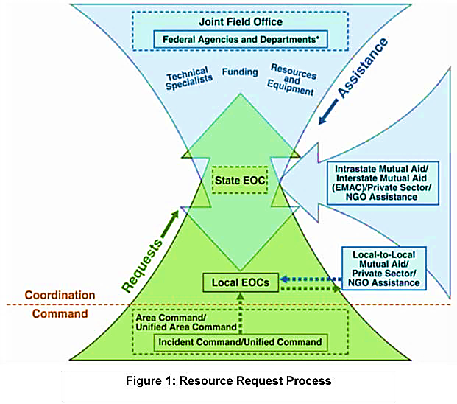

# INFORMATION COLLECTION, ANALYSIS, AND DISSEMINATION

## INFORMATION COLLECTION

Information collection, analysis, and sharing are vital to the successful response to and recovery from any disaster. The types of information needed during an event can change depending on the nature of the emergency. The following are certain types of information that are generally required, the source of the information, and specific times information is needed.

### Damage Assessments

* Completed by the Fayette County Department of Homeland Security and Emergency Management Director
* Completed within 48 hours after the disaster has taken place

### Incident Action Plans (IAPs)

* Completed by the Planning Section in cooperation with other EOC Section Chief, EOC Manager and EMA Director
* IAPs should be ready for review at least 1 hour prior to the beginning of an operational period. Once approved, they should be disseminated to all EOC staff and incident responders.

### Shelter Population

* Completed by ESF-6 and forwarded to the Operations Section Chief
* This information should be available with real time figures upon request of any party requiring the information of operations, planning, logistics, or finance objectives.

### Weather Updates

* Completed by the Situation Unit Leader and forwarded to the Planning Section Chief
* This information should be available with real time figures upon request of any party requiring the information of operations, planning, logistics, or finance objectives.

### Law Enforcement Sensitive Information

* Completed by ESF-15 and forwarded to the Operations Section Chief.
* This information will be made available and disseminated only to those individuals who demonstrate a valid “need to know.” The Law Enforcement Branch will determine when if information needs to be disseminated.

Developing a Common Operating Picture (COP) for emergency management partners is essential to ensuring effective and coordinated response and recovery operations. This section describes how essential event information will be collected, analyzed, and disseminated to appropriate stakeholders to provide a reliable, relevant, accurate and timely COP.

To ensure an effective intelligence flow, emergency response agencies at all levels must establish communications systems and protocols to organize, integrate and coordinate intelligence among the affected agencies.

Indiana utilizes a web-based, crisis, information management system known as WebEOC. The primary objective of WebEOC is to provide key personnel with a platform to share, analyze and manage emergency management and homeland security information throughout the State. The system has resource management capabilities to share information and track critical missions and tasks. WebEOC is a vital daily operations tool for the purpose of organizing, managing, and sharing critical information before an emergency or disaster. Access to WebEOC is limited to local, state, and federal homeland security partners who have an operational need to utilize this collaborative tool. Non-governmental and private sector partners are provided access on a case-by-case basis based on need.

Stakeholders, local emergency management agencies and Emergency Support Functions (ESF) organizations for example, are requested to update WebEOC with situational updates. If the county response capabilities are overwhelmed or depleted, local officials may request assistance from the State. Counties in need of State assistance will submit all requests (through the county Emergency Management Agency) to the Indiana Department of Homeland Security (IDHS) through the online WebEOC portal or by calling the IDHS Watch Desk.

Information may flow from the County into the State Emergency Operations Center (SEOC) through various communication channels and may be from several sources including government agencies at all levels, NGOs, the private sector, and the general public.

The EOC staff process incoming information into the following five broad categories for handling:

* Requests for Assistance
* Situation Information
* Offers of Assistance
* Inquiries
* Non-emergency

The National Incident Management System outlines a wide variety of methods utilized by personnel to accomplish data gathering:

* Obtaining data from 911 calls from public safety telecommunicators or from dispatch systems
* Monitoring radio, video and/or data communications among responders
* Reading SITREPs
* Using technical specialists such as National Weather Service representatives
* Receiving reports from field observers, ICPs, Area Commands, MAC Groups, and other EOCs
* Deploying information specialists to EOCs, other facilities and operational field offices
* Analyzing relevant geospatial products; and monitoring print, online, broadcast, and social media

A data collection plan will be established to standardize the recurring process of collecting critical information. This type of plan is usually a matrix that describes what essential elements of information (EEI) would be required for informed decision making from an all-hazards perspective. A dashboard indicating the status of a lifeline during an event with a color-coded/stoplight status will be utilized as applicable. Static datasets that can have cascading impacts/failures of critical infrastructure and their impacts to the lifelines to help determine response priorities include, but are not limited to, roads, power plants, power lines and hospitals. Live operational datasets that can depict actual impact for response and recovery efforts include, but are not limited to, emergency communications, shelter status, road closures, power outages, water status and hospital status.

### EMERGENCY OPERATIONS CENTER (EOC) AND FUSION CENTER COORDINATION

The collaboration between County EOC’s and fusion centers is critical. The development, implementation and maintaining a plan and procedures that creates a common understanding of roles and responsibilities. According to FEMA, the plan and procedures also ensure that intelligence and analysis capabilities can be leveraged to support emergency management operation activities when incidents require such a response. Both entities will provide a list outlining the products, reports, and capabilities each possesses to enhance the planning and response efforts.

EOC’s and fusion centers shall plan to utilize secure software applications and databases to share critical information. Privacy policies and other standard operating procedures (SOP’s) relating to information gathering, analysis and dissemination policies for both entities must be understood and agreed upon. A Memorandum of Understanding (MOU) between an EOC and fusion centers will also be considered that outlines all of the need requirements, policies, procedures, and expectations.

### P1503#y1FIGURE 11. EOC AND FUSION CENTER EFFECTIVE COORDINATION STEPS

### ANALYSIS AND DISSEMINATION

Essential Elements of Information (EEI’s) are crucial information requirements related to an event that are needed by the senior decision makers. EEI’s allow for analysis of all available information together to assist decision makers in reaching logical decisions based on the latest details related to the incident.

Key information is shared with partners through various reports and collaboration for situational awareness, decision making purposes and intelligence gathering as appropriate. Situational awareness staff analyze validated data to determine its implications for incident management and to turn raw data into information that is useful for decision making. Analysis addresses the incident’s information needs by breaking those information needs into smaller, more manageable elements and then addressing those elements. Executive Summaries, Situation Reports and other special bulletins are disseminated from the EOC to relevant partners. Federal systems are also utilized for critical and sensitive information sharing with federal partners including the Homeland Security Information Network (HSIN) and other secure systems.

# COMMUNICATIONS

The Integrated Public Alert and Warning System (IPAWS) provides integrated alert and warning services to local, state, tribal, territorial, insular area, and Federal authorities. IPAWS addresses the general public, including individuals with access and functional needs, such as individuals with disabilities, those from religious and racial and ethnically diverse backgrounds and people with limited English proficiency. IPAWS allows authorized alerting authorities to send one message which is disseminated simultaneously through multiple communications methods and devices to reach as many people as possible to save lives and protect property.

IPAWS allows the President and/or delegated officials to address the American people during all emergency or disaster circumstances. IPAWS enables local, state, tribal, territorial, insular area and Federal alert and warning emergency communication officials to access multiple broadcast and other Common Alerting Protocol compliant communications pathways such as the Emergency Alert System (EAS), Wireless Emergency Alerts (WEA) (formerly known as Commercial Mobile Alert System (CMAS)) and National Weather Service (NWS) Dissemination Systems and other unique alerting technologies, for the purpose of creating and activating alert and warning messages. Figure 12 demonstrates the IPAWS architecture.

FIGURE 12. INTEGRATED PUBLIC ALERT AND WARNING SYSTEM (IPAWS) ARCHITECTURE

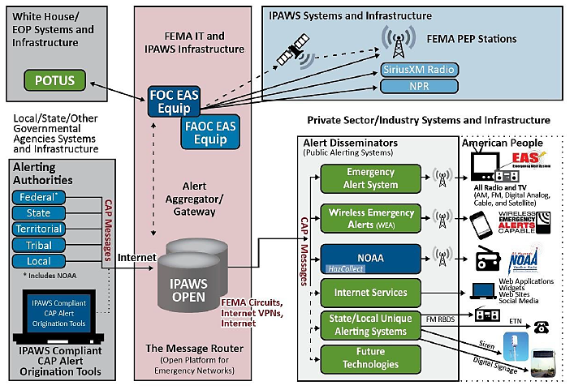

The WEA component of IPAWS provides an interface to participating mobile service providers for the delivery of alert information to individual mobile devices located within the affected area. The IPAWS WEA capability provides public safety officials with the ability to send 90 character, geographically targeted, text-like alerts to the public, warning of imminent threats to life and property. The cellular industry is a critical partner in the implementation and operation of this alert capability.

The Emergency Alert System (EAS) is a national public warning system that requires broadcasters, cable television systems, wireless cable systems, satellite digital audio radio service providers and direct broadcast satellite providers to provide communications capability to the President and/or delegated officials to address the American people during a national emergency. The system may also be used by local, state, tribal, territorial, and insular area authorities to deliver important emergency information such as imminent threats, weather information, America’s Missing: Broadcasting Emergency Response (AMBER) alerts and local incident information. The EAS is regulated by the Federal Communications Commission (FCC) and is managed by FEMA. In the event of a Presidential activation of the EAS, FEMA activates the EAS through the FEMA Operations Center. The distribution of EAS messages is reflected in Figure 13.

### Diagram Description automatically generated FIGURE 13. EMERGENCY ALERT SYSTEM

To ensure effective communication and information flow, emergency response agencies at all levels must establish communications systems and protocols to organize integrate and coordinate information among the affected agencies.

The following is a list of identified potential alternative communications, assuming that landline, wireless communication devices and internet are primary sources of communication. Any of these can be primary forms of communications. Any of these can be used alone or in conjunction with other communication systems. One or all may be operable at any given time within the state.

### COMMUNICATION METHODS

* Data including: WebEOC, Email, Text, Social Media, and Microsoft Teams Meetings
* Integrated Public Alert and Warning System (IPAWS)
* Emergency Alert System (EAS)
* Wireless Emergency Alerts (WEA)
* Konexus/CIVIC Alert
* National Oceanic and Atmospheric Administration (NOAA) All-Hazard Weather Radio
* Indiana Department of Transportation (INDOT) Signage
* Amateur Radio
* Alternative Local Emergency Management Agency (EMA) Website
* Non-traditional avenues: Private Sector Partners and Translation Services
* Government Emergency Telecommunications Service (GETS)
* 800 MHz Radio System
* Mutual Aid repeater system
* Indiana Law Enforcement Emergency Network (ILEEN)
* Satellite Radio/Phones
* Broadband Global Area Network (BGAN)
* Radio Emergency Associated Communications Teams (REACT)
* Military Affiliate Radio System (MARS)
* Runners

# ADMINISTRATION, FINANCE AND LOGISTICS

## ADMINISTRATION

### DOCUMENTATION

Various processes are used to track disaster response and recovery operations in **Fayette County**. WebEOC, HSIN and spreadsheets are examples of systems utilized to document planning, operations, logistics, response, and recovery operations for an incident. **Spreadsheets** are utilized to track personnel, financial and county assets.

## FINANCE

### COUNTY FINANCIAL MANAGEMENT

The Fayette County Auditor and/or The City of Connersville Clerk will be brought in during multi-incidents events to manage county and/or city finances

### STATE FINANCIAL MANAGEMENT RESPONSIBILITIES

*The IDHS Executive Director will identify and attempt to acquire emergency funds for the This section provides financial management guidance to the Indiana Department of Homeland Security and other offices to ensure funds are provided and financial operations are conducted in accordance with County, State and Federal policies and procedures during the response and recovery phases of an emergency or disaster.*

*The policy of the State of Indiana, as identified in* [*Indiana Code 10-14-3-32*](http://www.in.gov/legislative/ic/code/title10/ar14/ch3.html)*, ensures funds will always be available to meet the needs for disasters and emergencies. If these regularly appropriated funds for State and local agencies are inadequate to cope with a particular disaster or emergency event, additional funding may be available from the Governor’s Contingency Fund under the provisions of* [*Indiana Code 4-12-1-15*](http://www.in.gov/legislative/ic/code/title4/ar12/ch1.html) *and* [*10-14-3-28*](http://www.in.gov/legislative/ic/code/title10/ar14/ch3.html)***.***

*Depending upon the magnitude and nature of the disaster event, Federal assistance and financial support may also be made available following an approved Governor’s Disaster Emergency Declaration. This assistance may be through financial reimbursement to the state or local eligible entity or through the tasking of federal assets to provide assistance. When an event is not large enough for federal support, the State Disaster Relief Fund under* [*Indiana Code 10-14-4*](http://www.in.gov/legislative/ic/code/title10/ar14/ch4.html) *may assist eligible entities with limited response and recovery costs.*

*response and recovery of the disaster emergency, direct efforts to secure additional emergency appropriations and designate a program manager for funds allocated to emergency response and recovery activities. The IDHS Executive Director or a designee may act on his/her behalf or absence pursuant to* [*Indiana Code 10-19-3-5*](http://www.in.gov/legislative/ic/code/title10/ar19/ch3.html)*, to acquire funds for response and recovery activities.*

*The primary individual charged with the responsibility to collect, organize, report, and disseminate disaster funds will be the IDHS Chief Financial Officer (CFO). The CFO will ensure the following is completed:*

* *During the response phase, serve as primary advisor to the Executive Director or designee on all financial matters.*
* *The CFO has signature authority for funds allocated to an emergency or disaster.*
* *The CFO will work closely with program managers to ensure proper management of funds.*

*The IDHS Emergency Management Division Director will act as the primary coordinator for disaster operations and will outline critical resources, equipment and services which may require the expenditure of funds to manage and stabilize emergency situations.*

### FAYETTE COUNTY FINANCIAL MANAGEMENT OPERATIONS

*Timely financial support of response activities will be critical to successful emergency response. Innovative and expeditious means may be used to achieve financial objectives. It is mandatory for generally accepted state financial policies, principles, and regulations to be employed to ensure against fraud, waste, and abuse and to achieve proper control and use of public funds.*

*The procurement of resources will be in accordance with the Indiana Department of Administration (IDOA) and statutory requirements for established procedures regarding emergency and non-emergency conditions.*

*Each agency is responsible for providing its own financial services and support to its response operations in the field, as well as the recording and retention of all financial documentation. Funds to cover eligible costs for response activities may be dispersed through IDHS.*

*The following key tasks for financial operations should be considered to effectively support and manage funding for emergency activities:*

### PREVENTION FUNDING

Each agency should apply for grants and/or budget monies to help mitigate the cost for equipment which will aid in the prevention of a terrorism event.

### PREPAREDNESS FUNDING

Each agency should prepare for future emergency budgets by studying past emergency responses and identifying needs not met by their current budget. Contingencies, such as mutual aid and agency partnerships, are a way to address unmet needs*.*

### MITIGATION FUNDING

**Each agency is required to use finances from their own budgets to mitigate potential emergency situations affecting their agency’s ability to respond to and recover from emergencies.**

### RESPONSE FUNDING

*After a Governor’s Disaster Emergency Declaration, State agencies may be required to spend more than their allocated budget to respond effectively to the emergency. After State agencies begin their initial response operations, it may be necessary to prepare and submit a report on the estimated funding needs for the duration of the emergency response. The purpose of the estimate is to help establish the need for additional allocation from the Governor’s Contingency Fund or supplemental or special legislative appropriations.*

### RECOVERY FUNDING

[*Indiana Code 4-12-1-15*](http://www.in.gov/legislative/ic/code/title4/ar12/ch1.html) *states emergency or contingency funds may be appropriated for the repair or replacement of any building or equipment, which has been destroyed, or has been so damaged as to materially affect public safety. In addition, the State Disaster Relief Fund per* [*Indiana Code 10-14-4*](http://www.in.gov/legislative/ic/code/title10/ar14/ch4.html) *may be available to provide financial assistance to eligible local government entities for “the costs of repairing, replacing, or restoring public facilities or individual residential real or personal property damaged or destroyed” by a declared disaster that does not result in federal assistance.*

### RECOVERY OF COSTS

When an event occurs the Recovery Branch monitors the event to determine if sufficient damage has been sustained to merit a declaration of emergency. The declaration request is based upon verification of local damage reports and may take two forms. If damages are limited to local businesses and residential properties, the State may request a US Small Business Administration Disaster Declaration. This declaration will make available disaster recovery loans for eligible applicants. A second declaration would be a State Declaration made through the Governor’s Executive Order process. These declarations open the doors, if sufficient damages have been verified, for a Federal Disaster Declaration with FEMA, or Federal Highway Disaster Funds for Roadway damages. Should the event be more localized the governor’s executive order may open the State Disaster Relief Fund for local government entities disaster recovery.

### VOLUNTEER LABOR AND RESOURCES

Volunteer labor is not directly reimbursed, but rather, during a FEMA declaration is credited to the applicant for their 25% local match. Volunteers must be rostered, as well as identifying the hours of service and the location of and type of work completed. Any mutual aid services must be requested by the recipient of the services and must be claimed by the recipient of such services. Documentation of the mutual aid agreement and billing habits must also be documented. If an agency is billing for a disaster event in order to receive federal funds, they must also be able to show routine billing for non-declared mutual aid efforts. All documentation must be in accordance with the FEMA policies and current PAPPG in effect at the time of the disaster event.

### REBUILDING PROGRAMS

Indiana has an active network of volunteer organizations which assist both during the response and recovery phases of a disaster event. The INVOAD, Indiana Voluntary Organizations Active in Disaster provide disaster survivors with immediate needs assistance during and immediately after an event, as well as working with the County Organizations Active in Disaster (COAD) and the Long-Term Recovery Groups (LTRG) to assure all event survivors with unmet needs are addressed. These groups work closely with the State Volunteer Assistance Liaison (VAL) and the Indiana Recovery Branch personnel to ensure efforts are not duplicated. This network works closely with local authorities to make survivors aware of assistance to complete their recovery. Assistance may include US SBA declarations and loans, FEMA Individual and Household Program assistance, disaster unemployment assistance, food assistance programs, etc.

### FINANCIAL RECORDS AND SUPPORTING DOCUMENTATION

**All agencies must maintain records, receipts, and documents to support claims, purchases, reimbursements, and disbursements. Reimbursement requests will be documented with specific details on personnel services, travel, and other expenses.**

Agencies requesting reimbursements will maintain all financial records, supporting documents, statistical records, and other records pertinent to the provision of services or use of resources by that agency. These materials must be accessible to authorized representatives for the purpose of making audits, excerpts, and transcripts.

### DOCUMENT RECOVERY COSTS

Irrespective of declaration source, expenditure documentation is required for successful reimbursement. Personnel costs for response and recovery activities (straight and overtime) must be documented with time expended and the nature and location of work completed. Equipment usage must also be documented including the operator, amount of time used and a full description of the equipment so it may be appropriately categorized using FEMA equipment rates or other approved rates. (Most equipment rates are based on hours of use and include fuel, maintenance and routine wear and tear costs as well as the hourly operations costs.) Additionally, Supplies and material costs must be recorded to include the source of the materials/supplies (stockpile or newly acquired) the costs per unit and the location and/or nature of the use. Receipts are required for all purchases. Rental equipment and contract services must include the procurement method used to acquire the services as well as the costs and source information.

### COST RECOVERY PROCESS TRAINING

*The recovery staff at IDHS host training sessions on disaster declaration, damage assessment, FEMA portal, debris management, etc. Damage assessment for individuals and households training is also available from the IDHS team on a virtual platform. The FEMA portal training is also available through the Emergency Management Institute (EMI) Independent Study (IS) program IS1000 series courses.*

### IMPACT OF INSURANCE

Disaster Assistance is not meant to make an applicant whole; it is meant to address the basic needs to begin a successful recovery process. Insurance is key for people to be able to properly address their recovery needs and to return to a level similar to pre-event. The National Flood Insurance Program addresses damages due to flood events. All properties are eligible to purchase flood insurance. Flood insurance participation is relatively low due to the high cost. Homeowner’s policies are key for wind and fire events but require additional writers for such items as sewer back up, sump pump failure and earthquake coverage. Whenever insurance is in force, the insurance benefits must be claimed prior to receiving any disaster assistance. Insurance benefits may not be duplicated by disaster assistance.

### LEGAL DOCUMENTATION REQUIREMENTS

The documentation required for disaster assistance includes verification of procurement methods along with verification of costs using standard payroll and purchasing process documentation. Under the State Disaster Relief Fund, the program records include an audit requirement within 3 years of the grant release. After FEMA declarations, the local government entity records are audited by the state board of accounts during routine audits.

### AUDIT OF EXPENDITURES

*The expenditure of State and federal funds related to emergencies or disasters are subject to audit in accordance with State and federal statutes and audit procedures.*

### GUIDANCE FOR FINANCIAL MANAGEMENT OPERATIONS

*The IDHS Chief Financial Officer will provide written guidance and technical assistance in the support of financial operations for the State of Indiana as it relates to emergency and disaster activities. This guidance describes the appropriate methods for agencies and departments to collect, maintain and submit information on their financial management activities. The guidance will be based on federal and state laws, policies, and programs available to financially assist. Each of the IDHS recovery programs which includes Individual Assistance (IA), Public Assistance (PA) and the Mitigation and State Disaster Relief Fund (SDRF) have administrative plans address financial and program management process and details for each individual program.*

## LOGISTICS

The County EOC Logistics Section acts as the County resource management entity before, during and after emergency events.

The Logistics Section is primarily focused on coordinating the acquisition, deployment and distribution of needed resources, supplies, systems, and commodities through the establishment of an effective supply chain.

The Logistics Section ensures transportation requirements and requests for facilities and support are addressed including Commodity Points of Distribution and County Logistical Staging Areas.

Additionally, the Logistics Section:

* Coordinates the procurement of needed resources with the Finance Section.
* Engages with the Operations Section on missions requiring additional assistance through partner agencies, NGOs, and the private sector.
* Coordinates mutual aid through Emergency Management Assistance Compact.
* Feeds and supplies hydration to County and City First Responders.

The County EOP includes the County Logistics Annex and multiple Appendices which contain detailed information on Fayette County’s logistical capabilities.

# PLAN DEVELOPMENT AND MAINTENANCE

A hardcopy or electronic version of the full Fayette County Department of Homeland Security and Emergency ManagementCounty EOP is provided to all county department heads, local municipalities, and key stakeholders. Distribution is intentionally limited as this document is designated as **Classified// For Official Use Only (C//FOUO)**.

An EOP is a living document that is continuously revised and updated as needed. Revisions are often made when there is a change in policy, a need to amend specific action guidance or there are new requirements to meet State or Federal standards. The EOP is designed and structured so that changes can be made to a specific section or annex.

The EOP shall be reviewed annually for possible revision and updated at least every two (2)years. The EOP may also be reviewed for necessary changes based upon recommendations of an exercise or actual event After-Action Report / Improvement Plan (AAR/IP) or at the request of a coordinating or primary agency within an annex.

Whenever significant changes are made to it, they shall be noted in the EOP Record of Changes log maintained at the Fayette County Department of Homeland Security and Emergency Managementoffice. All recipients of the EOP via a distribution list shall be provided a notice of change or copy of change.

Any previous additions of an EOP, EAG or specific annex should be discarded. The distribution list is an EOP appendix.

# TRAINING, EXERCISE, VALIDATION AND CORRECTIVE ACTION

## TRAINING

**Fayette County** is committed to proactive leadership and sound fiscal practices. The Fayette County Department of Homeland Security and Emergency Management’semergency management program is comprehensive and emphasizes a whole community inclusion approach to planning and preparedness efforts. For Incident Command System (ICS) training, the County EMA Director coordinates with the Indiana Department of Homeland Security (IDHS) Training Section to coordinate training courses to increase the county level of preparedness. All County personnel involved in incidents are strongly encouraged to attend training. Just-In-Time (JIT) training can be provided in group or individual settings based on the need.

The state training calendar and course registration is available on the Indiana [Public Safety Personnel Portal](https://acadisportal.in.gov/AcadisViewer/Login.aspx) also known as Acadis. The **Acadis Portal** is a training management tool to better serve emergency managers, firefighters, law enforcement, emergency medical services, public works, public health, volunteer organizations, elected and appointed officials and others throughout the state with their training needs. Acadis tracks courses completed and certifications as well as exercises completed utilizing a unique Public Safety Identification (PSID) number for each individual.

## EXERCISE

The Fayette County Department of Homeland Security and Emergency Management Director coordinates all local exercise activity and establishes with other district EMA Directors a schedule of district-level exercises that will be supported by the IDHS State Exercise staff. IDHS utilizes the Homeland Security Exercise and Evaluation Program (HSEEP). HSEEP is the national standard for exercise design and implementation. HSEEP incorporates the National Preparedness Goal’s 32 Core Capabilities as a standardized methodology to evaluate and document exercises and develop improvement plans.

Exercise frequency and schedule will be determined at the Indiana Integrated Preparedness Planning Workshop (IPPW). The number of personnel involved in the exercise must be sufficient for carrying out those measures required by the incident scenario. The exercises will be evaluated according to the HSEEP principles. An exercise program enables testing of plans, procedures, protocols, internal coordination and practicing coordination with external response entities. Depending on the scope and scale of the emergency preparedness exercises, they may involve many individuals, both internal and external.

### FIGURE 14. PLANNING/TRAINING/CAPABILITY EXERCISE CYCLE

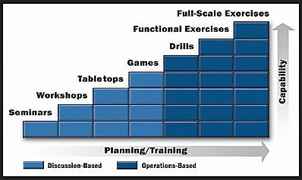

### DISCUSSION-BASED EXERCISES

**Seminars:** Orient participants or provide an overview of plans, policies, and procedures

**Workshops:** Focus on development of a product by the attendees

**Tabletop Exercises:** Assess plans, policies and procedures regarding a hypothetical, simulated emergency.

**Games:** Simulation of operations that often involves two or more teams designed to depict an actual or hypothetical situation

### OPERATIONS-BASED EXERCISES

**Drills:** Test a single operation or function in a single agency or organization

**Functional Exercises:** Test individual capabilities, multiple functions, or activities within a function; however, movement of personnel and equipment is usually simulated.

**Full-scale Exercises:** Test many facets of response and recovery and involves multiple agencies and jurisdictions.

# AUTHORITIES AND REFERENCES

Federal, state, and local statutes and their implementing regulations establish legal authority for development and maintenance of emergency management plans. The following pages provide a general overview of the roles and responsibilities of agencies which may be involved in an emergency response or in an emergency management operation. Each department/agency shall develop and maintain standard operating procedures in an agency Emergency Plan or Continuity of Operations Plan which supports this EOP.

### LOCAL AUTHORITY

Local Emergency Management Ordinances

***City - County Civil Defense Organization TITLE III CHAPTER 34 SECTION 34.06***

1. *There is hereby established in Fayette County a joint organization for civil defense to be operated in conformity with state law. This organization will be known as the Fayette County Civil Defense. A coordinator will be appointed for the organization, to serve during the pleasure of these bodies.*

*(B)   The County Auditor and Clerk-Treasurer of the city will be responsible for the receipt and disbursement of all civil defense funds, where funds are provided for civil defense purposes.*

*(Ord. 2021, passed 6-21-76)*

Local Emergency Management (EM) Ordinances are an extension of Indiana Code 10-14-3, at the local jurisdictional level. These local statutes spell out additional, jurisdictional-specific, or area-specific requirements the State law does not address. The Local EM Ordinances also provide the Local Emergency Management Director with the authority to act before, during and after an emergency or disaster and define the necessary requirements for establishing and maintaining an effective emergency management and public safety program for a given jurisdiction.

Emergency Operations Plans

These documents are the multi-discipline, all-hazards plans modeled after the State EOP and the National Response Framework (NRF) for local jurisdictions within the State of Indiana. The plans provide for a single, comprehensive framework for the management of emergency and disaster events within a given jurisdiction. Local Comprehensive Emergency Management Plans (LCEMPs) outline structure and mechanisms for coordinating local preparedness and response activities. The LCEMP also acts as a general reference point for local agencies to develop contingencies to meet the needs of their communities during emergency or disaster events.

### STATE AUTHORITY

### INdiana Code 10-19-2

This Indiana Code establishes the Department of Homeland Security in the State of Indiana.

Indiana Code 10-14-3. Emergency Management and Disaster Law

This Indiana Code is the primary guideline for establishing and coordinating local emergency management programs and provides information on the disaster declaration process, emergency planning and other pertinent requirements for successful public safety programs.

Indiana Code 10-14-5. Emergency Management Assistance Compact

The purpose of this compact is to provide for mutual assistance among the states entering into this compact in managing any emergency or disaster which is duly declared by the governor of the affected State, whether arising from natural disaster, technological hazard, man-made disaster, civil emergency aspects of resources shortages, community disorders, insurgency, or enemy attack.

**Indiana Code 16-19-3**

This Indiana Code gives the Indiana State Department of Health the authority to act to protect the health and lives of the citizens of the State of Indiana. The code also gives this department “all powers necessary to fulfill the duties prescribed in the statutes and to bring action in the courts for the enforcement of the health laws and health rules.”

Executive Order 17-02, January 9, 2017

Establishes and clarifies duties of State agencies for all matters relating to emergency management and designates the Executive Director of the Indiana Department of Homeland Security as the State Coordinating Officer for all emergency and disaster prevention, protection, mitigation, response, and recovery operations for the State of Indiana.

### FEDERAL AUTHORITY

42 United States Code 11001 et seq., Superfund Amendment and Reauthorization Act of 1986, Title III, This Code establishes State emergency response commissions, emergency planning districts and local emergency planning committees and their associated regulations.

Occupational Safety and Health Administration (OSHA), Hazardous Waste Operations and Emergency Response (HAZWOPER), 29 CFR 1910.120, 1986

This OSHA standard includes safety requirements employers must meet in order to conduct five specific types of hazardous waste operations.

5121 et seq., November 23, 1988

This federal law establishes and provides direction for federal and state government entities affected by emergencies and disasters and the means and methods necessary to declare and seek reimbursement and monies to support recovery efforts

This Code governs the policies, procedures and programs regarding State and local emergency management assistance required and provided by the Federal Emergency Management Agency (FEMA).

National Oil and Hazardous Substances Pollution Contingency Plan, 1994

The National Oil and Hazardous Substances Pollution Contingency Plan, more commonly called the National Contingency Plan or NCP, is the federal government's blueprint for responding to both oil spills and hazardous substance releases. The National Contingency Plan is the result of our country's efforts to develop a national response capability and promote overall coordination among the hierarchy of responders and contingency plans.

Act, June 12, 2002

Also known as, the Bioterrorism Act of 2002; this law establishes guidance and directives for the prevention, tracking and reporting of potential or actual events of bioterrorism within the United States. It focuses the public health response personnel toward a number of preparedness activities, which include emergency planning, training, and exercises. It also provides for funding of public health initiatives such as public outreach and equipping personnel for bioterrorism threats.

Homeland Security Act of 2002, November 25, 2002

This Act establishes the United States Department of Homeland Security and organizes existing agencies and departments at the federal level into an overall structure to support the protection of the American Homeland.

Presidential Policy Directive 5, February 28, 2003

This Presidential Executive Order establishes and directs the development of the National Incident Management System (NIMS) for the purpose of managing and coordinating major natural or human-caused hazards at the federal, state, and local jurisdictional levels. Additionally, NIMS is now a requirement for all state and local entities receiving federal preparedness assistance through grants, contracts, or other activities.

Presidential Policy Directive 7, December 17, 2003

This Presidential Executive Order establishes a national policy for federal departments and agencies to identify and prioritize critical infrastructure and key resources in the United States with the purpose of protecting these locations from terrorist attacks.

Presidential Policy Directive 8, December 17, 2003

Presidential Policy Directive 8 establishes policies to strengthen the preparedness of the United States to prevent and respond to threatened or actual domestic terrorist attacks, major disasters, and other emergencies by requiring a national domestic all-hazards preparedness goal. PPD 8 establishes mechanisms for improved delivery of federal preparedness assistance to State and local governments and outlining actions to strengthen preparedness capabilities of federal, state, and local entities.

Presidential Policy Directive 9, January 30, 2004

This Directive establishes a national policy to defend the agriculture and food system against terrorist attacks, major disasters, and other emergencies.

**Presidential Policy Directive 21, Feb 12, 2013**

*Critical Infrastructure Security and Resilience*, This directive establishes national policy on critical infrastructure security and resilience. This endeavor is a shared responsibility among the Federal, state, local, tribal, and territorial (SLTT) entities, public and private owners and operators of critical infrastructure.

**Presidential Policy Directive 40**

Also known as the National Continuity Policy, is a US federal government initiative that requires agencies to be able to continue performing essential functions in a variety of circumstances.

U.S. Department of Homeland Security, National Incident Management System (NIMS), December 2008

This document provides background information on the National Incident Management System (NIMS), which includes a detailed explanation of the core set of concepts and principles of which the program is comprised. These components include command and management, preparedness, resource management, communication, and information management, supporting technologies and ongoing management and maintenance.

National Preparedness Goal September 2011

The National Preparedness Goal reflects a whole community approach which focuses on the capabilities necessary to prevent, protect against, mitigate, respond to, and recover from the threats and hazards which pose the greatest risk to the Nation.

National Disaster Recovery Framework June 2016

The National Disaster Recovery Framework describes context for how the whole community works together to restore, redevelop, and revitalize the community following a disaster. The intended audience for this document is individuals, families, communities, the private and nonprofit sectors, faith- based organizations, local, state, tribal, territorial, insular area, and Federal governments.

National Mitigation Framework June 2016

The National Mitigation Framework describes the benefits of being prepared by understanding risks and what actions can help address those risks. The intended audience for this document is individuals, families, communities, the private and nonprofit sectors, faith-based organizations, local, state, tribal, territorial, insular area, and Federal governments.

National Prevention Framework June 2016

The National Prevention Framework describes how the whole community plays an important role in assisting with the prevention of imminent terrorist attacks. The intended audience for this document is individuals, families, communities, the private and nonprofit sectors, faith-based organizations, local, state, tribal, territorial, insular area, and Federal governments.

National Protection Framework June 2016

The National Protection Framework describes the way which the whole community safeguards against acts of terrorism, natural disasters and other threats or hazards. The Protection processes and guiding principles contained in this framework provide a unifying approach which is adaptable to specific Protection mission requirements, mission activities, jurisdictions, and sectors.

National Response Framework June 2016

The National Response Framework describes not only how the Federal government organizes itself to respond to natural disasters, terrorist attacks and other catastrophic events, but also the importance of the whole community in assisting with response efforts. The intended audience for this document is individuals, families, communities, the private and nonprofit sectors, faith-based organizations, local, state, tribal, territorial, insular area, and Federal governments.

# ANNEX A - HAZARDS AND THREATS FROM HIRA

The Hazard Identification Risk Assessment (HIRA) is an annual quantitative process in which jurisdictions select all natural, human-caused, or technological hazards or threats that present the greatest risk to the community. The assessment is embedded in WebEOC, and drop-down menus are selected for probability, magnitude/severity, warning time and duration of threats and hazards. Calculations are auto populated. Figure 15 provides Fayette County’s methodology.

### FIGURE 15. 2024 FAYETTE COUNTY HIRA SELF-ASSESSMENT

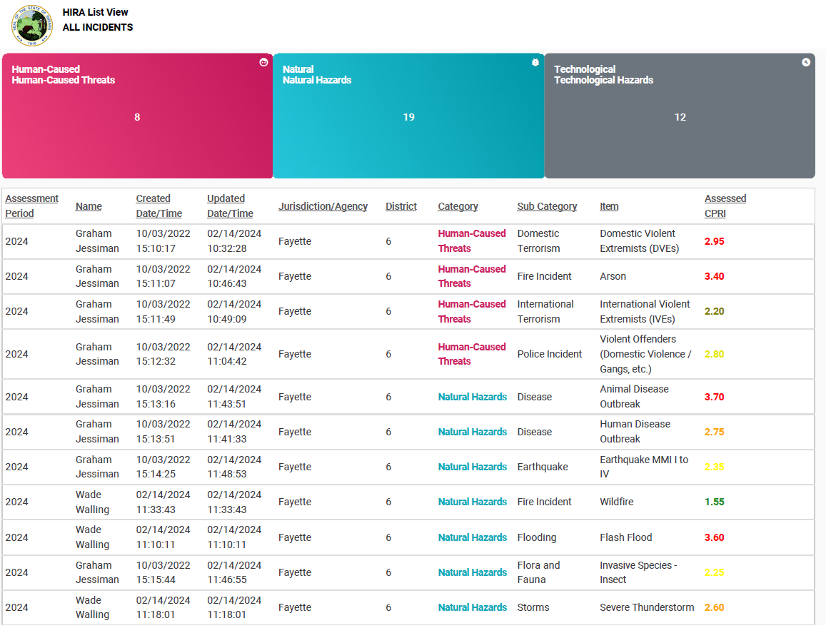

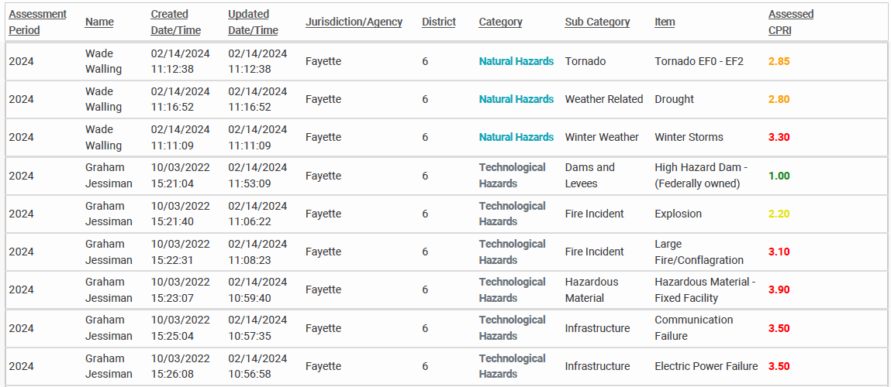

### TABLE 7. CALCULATED PRIORITY RISK INDEX (CPRI) FORMULAP1778#y1

|  |
| --- |
| **CALCULATED PRIORITY RISK INDEX (CPRI) FORMULA** |
| **(Probability x 0.45) + (Severity/Magnitude x 0.30) + (Warning Time x 0.15) + (Duration x 0.10) = CPRI SCORE** |

TABLE 8. CALCULATED PROBABILITY RISK INDEX (CPRI) RATING SCALE

|  |  |
| --- | --- |
| **RISK RATING** | **CPRI SCORE** |
| **Severe Risk** | **2.91 – 4.00** |
| **High Risk** | **2.51 – 2.90** |
| **Moderate Risk** | **2.00 – 2.50** |
| **Low Risk** | **< 1.99** |

### TABLE 9. HAZARD AND THREAT RISK RATINGS

|  |  |
| --- | --- |
| **HAZARD AND THREAT RISK RATINGS – SEVERE RISK - 2.91 – 4.00** | |
| **CPRI RATING** | **HAZARD/THREAT** |
| 3.90 | Hazardous Material Fixed Facility |
| 3.70 | Animal Disease Outbreak  Outbreak |
| 3.60 | Flash Flood |
| 3.50 | Communication Failure |
| 3.50 | Electric Power Failure |
| 3.40 | Fire Incident (arson) |
| 3.10 | Large Fire/Conflagration |
| 2.95 | Domestic Violent Extremists (DVEs) |
| **HAZARD AND THREAT RISK RATINGS – HIGH RISK - 2.51 – 2.90** | |
| **CPRI RATING** | **HAZARD/THREAT** |
| 2.85 | Tornado EF0-EF2 |
| 2.80 | Police Incident-Violent Offenders (Domestic Violence / Gangs, etc.) |
| 2.80 | Drought |
| 2.75 | Human Disease Outbreak |
| 2.60 | Severe Thunderstorm |
| **HAZARD AND THREAT RISK RATINGS – MODERATE RISK - 2.00 – 2.50** | |
| **CPRI RATING** | **HAZARD/THREAT** |
| **2.35** | Earthquake MMI I to IV  IV |
| 2.25 | Invasive Species - Insects  Insect |
| 2.20 | Fire Incident (Explosion) |
| 2.20 | International Violent Extremists (IVEs) |
| **HAZARD AND THREAT RISK RATINGS – LOW RISK < 1.99** | |
| **CPRI RATING** | **HAZARD/THREAT** |
| 1.55 | Fire Incident (Wildfire) |
| 1.00 | High Hazard Dam (Federal Owned) |
|  |  |
|  |  |
|  |  |
|  |  |
|  |  |
|  |  |
|  |  |
|  |  |
|  |  |
|  |  |
|  |  |
|  |  |

# ANNEX B – ESF PRIMARY AND SECONDARY AGENCIES

|  |  |  |  |  |  |  |  |  |  |  |  |  |  |  |  |
| --- | --- | --- | --- | --- | --- | --- | --- | --- | --- | --- | --- | --- | --- | --- | --- |
| **FAYETTE COUNTY** **RESPONSIBILITY MATRIX**  **(P=Primary, S=Secondary)** | | | | | | | | | | | | | | | |
| **AGENCIES / ORGANIZATIONS** | | | | | | | | | | | | | | | |
| **AGENCY/ESF** | **1** | **2** | **3** | **4** | **5** | **6** | **7** | **8** | **9** | **10** | **11** | **12** | **13** | **14** | **15** |
| **Fayette County Highway** | P |  |  |  |  |  |  |  |  |  |  |  |  |  |  |
| **City of Connersville Street Department** | P |  |  |  |  |  |  |  |  |  |  |  |  |  |  |
| **Fayette County**  Central Dispatch |  | P |  |  |  |  |  |  |  |  |  |  |  |  |  |
| **Fayette County**  Emergency Management |  | S |  |  |  |  |  |  |  |  |  |  |  |  |  |
| **City of Connersville**  **Public Works Dept.** |  |  | P |  |  |  |  |  |  |  |  |  |  |  |  |
| **Connersville City Fire dept.** |  |  |  | P |  |  |  |  |  |  |  |  |  |  |  |
| **Bentonville Fire Dept.** |  |  |  | P |  |  |  |  |  |  |  |  |  |  |  |
| **Everton Fire Dept.** |  |  |  | P |  |  |  |  |  |  |  |  |  |  |  |
| **Glenwood Fire Dept.** |  |  |  | P |  |  |  |  |  |  |  |  |  |  |  |
| **FAYETTE COUNTY EMERGENCY MANAGEMENT** |  |  |  |  | P |  |  |  |  |  |  |  |  |  |  |
| **FAYETTE COUNTY EMS** |  |  |  |  |  |  |  | P |  |  |  |  |  |  |  |
| **Fayette County Sheriffs Dept.** |  |  |  |  |  |  |  |  |  |  |  |  | **P** |  |  |
| **Connersville city police dept.** |  |  |  |  |  |  |  |  |  |  |  |  | **P** |  |  |

# ANNEX C - COMMUNITY LIFELINES



Indiana has adopted the Federal Emergency Management Agency’s (FEMA) seven community lifelines into our prevention, protection, response, recovery, and mitigation activities. Lifelines are services that enable the continuous operation of critical government and business functions and are essential to human health and safety or economic security.

**Stabilizing community lifelines is the primary effort during response activities.**

**ESFs deliver core capabilities to stabilize community lifelines for an effective response.**

The seven community lifelines represent only the most basic services a community relies on and which, when stable, enable all other activity within a community. The lifelines are designed to enable emergency managers, infrastructure owners and operators and other partners to analyze the root cause of an incident impact and then prioritize and deploy resources to effectively stabilize the lifeline. This construct maximizes the effectiveness of federally supported, state managed and locally executed response.

Similar to the ESFs, other whole community organizations can work together to stabilize lifelines and meet disaster needs. The community lifelines do not directly cover all important aspects of community life that can be affected by an incident, including impacts to natural, historical, and cultural resources. For example, financial and economic issues important to the life and safety of affected individuals may also arise indirectly from impacts to lifelines during an incident. If disrupted, rapid stabilization of community lifelines is essential to restoring a sense of normalcy. Recent disasters have illuminated two underlying features of community lifelines that highlight opportunities to strengthen response planning and operations.

First, community lifelines are interdependent and vulnerable to cascading failures. For example, communications and electric power systems rely on each other to function; severe damage to one will disrupt the other. Most lifelines also rely on complex supply chains. Water and wastewater service depend on the resupply of a broad array of chemicals and—if power goes out—fuel for emergency generators. However, in a severe natural or human-caused incident, those supply chains themselves may be broken.

Second, community lifeline stabilization relies on businesses and infrastructure owners and operators who have the expertise and primary responsibility for managing their systems in emergencies. Accordingly, Indiana is working with developing planning coordination mechanisms needed to enable the private sector to play a larger, more comprehensive role in preparedness and response activities. The community lifelines are composed of multiple components that encompass infrastructure, assets, and services.

### FIGURE 16. COMMUNITY LIFELINE COMPONENTS AND SUB-COMPONENTS

|  |  |  |
| --- | --- | --- |
| **ALL COMMUNITY LIFELINE COMPONENTS AND SUB-COMPONENTS** | | |
| Multiple components establish the parameters of and key assessment elements for each of the lifelines; component-level analysis is required to determine if each lifeline is stable | | |
| **SAFETY AND SECURITY** | **FOOD, WATER, SHELTERING** | **HEALTH AND MEDICAL** |
| * + Hazard Mitigation   + Law Enforcement / Security   + Responder Safety   + Search and Rescue   + Fire Services   + P3844L59C6T19#y1Government Service | * + Evacuations   + Food / Potable Water   + Shelter   + Durable Goods     - Water Infrastructure     - Agriculture Infrastructure   P3854L59C7T19#y1 | * + Medical Care   + Patient Movement   + Public Health   + Fatality Management   + Medical Industry   P3860C8T19#y1 |
| **ENERGY** | **COMMUNICATIONS** | **TRANSPORTATION** |
| * + Power (Grid)   + Temporary Power   + Fuel   P3869L60C12T19#y1 | * + Infrastructure     - 911 & Dispatch     - Responder Communications   + P3873L60C13T19#y1Alerts, Warnings, Messages | * + Highway / Roadway Motor Vehicle   + Mass Transit   + P3878L60C14T19#y1Railway   + Aviation   + Maritime   + Pipeline |
| **HAZARDOUS MATERIAL** | | |
| * + P3884C16T19#y1Facilities   + Incident Debris, Pollutants, Contaminants   + Conveyance | | |

### FIGURE 17. LIFELINE, ESF AND CORE CAPABILITIES CROSSWALK

| LIFELINE SYMBOL | COMPONENTS | SUPPORTING ESF PLANNING TEAM | RELATED CORE CAPABILITIES |
| --- | --- | --- | --- |
|  | **Safety and Security**   * Law enforcement, security * Search and rescue * Fire services * Government service * Responder safety * Imminent hazard mitigation | * ESF 13* * ESF 1 * ESF 4 * ESF 5 * ESF 7 * ESF 9 * ESF 12 * ESF 14 * ESF 15 * INNG * Private security | * Planning * Public Information and Warning * Operational Coordination * Environmental Response/ Health and Safety * Fire Management and Suppression * Mass Search and Rescue Operations * On-scene Security, Protection, and Law Enforcement * Situational Assessment |
|  | **Food, Water, Sheltering**   * Evacuations * Food, potable water * Shelter * Durable goods * Water infrastructure * Agriculture | * ESF 6* * ESF 1 * ESF 3 * ESF 5 * ESF 7 * ESF 11 * ESF 13 * ESF14 * ESF15 * VOAD * INNG | * Planning * Public Information and Warning * Operational Coordination * Critical Transportation * Infrastructure Systems * Logistics and Supply Chain Management * Mass Care Services * Situational Assessment |
|  | **Health and Medical**   * Medical care * Patient movement * Public health * Fatality management * Healthcare supply chain * Fire service | * ESF 8* * ESF 1 * ESF 4 * ESF 5 * ESF 7 * ESF 14 * ESF 15 * INNG | * Planning * Public Information and Warning * Operational Coordination * Environmental Response/Health and Safety * Fatality Management Services * Logistics and Supply Chain Management * Public Health, Healthcare, and Emergency Medical Services * Situational Assessment |
|  | **Energy**   * Power (grid) * Temporary power * Fuel | * ESF 12* * ESF 3 * ESF 5 * ESF 7 * ESF 14 * ESF 15 | * Planning * Public Information and Warning * Operational Coordination * Infrastructure Systems * Logistics and Supply Chain Management * Situational Assessment |
|  | **Communications**   * Infrastructure * Alerts, warnings, messages * 911 and dispatch * Responder communications * Financial services | * ESF 2* * ESF 5 * ESF 7 * ESF 13 * ESF 14 * ESF 15 * INNG | * Planning * Public Information and Warning * Operational Coordination * Infrastructure Systems * Operational Communications * Situational Assessment |
|  | **Transportation**   * Highway, roadway * Mass transit * Railway * Aviation * Maritime * Pipeline | * ESF 1* * ESF 5 * ESF 7 * ESF 13 * ESF 14 * ESF 15 * INNG | * Planning * Public Information and Warning * Operational Coordination * Critical Transportation * Infrastructure Systems * Situational Assessment |
|  | **Hazardous Material**   * Facilities * Hazardous debris * Pollutants * Contaminants | * ESF 10* * ESF 4 * ESF 5 * ESF 7 * ESF 3 * ESF 14 * ESF 15 | * Planning * Public Information and Warning * Operational Coordination * Environmental Response/Health and Safety * Situational Assessment |
| **\***  **= Coordinating Unit** | | | |

## PLANNING

Planners are integrating the lifelines concept into the following planning functions:

Future Planning:

Incorporate lifeline concept into deliberate planning products, including defined stabilization targets for each lifeline.

Incident Action Planning:

Analyze impacts to the various lifelines and develop priority focus areas for each operational period. Support the development of strategy, operational priorities, and objectives.

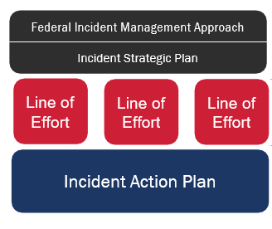Lifelines enable the measurement of planning.

**STRATEGIC LEVEL:** Strategy sets goals, tasks to achieve the goals, the resources required and any risks.

**OPERATIONAL LEVEL:**  Operational priorities request and direct specific resources to execute strategy.

**TACTICAL LEVEL:**  Objectives provide visibility on the progress stabilization efforts

## PLANS AND REPORTING

Lifelines reporting aims to provide situational awareness for:

* Taking a strategic approach to Incident Management and Incident Support
* Executing lines of effort to achieve lifeline stabilization.
* Establishing a concept of logistics support

It also provides guidance for and informs:

* Incident Management and Incident Support resource deployment decisions (e.g., contracts, Resource Request Forms, Mission Assignments and FEMA personnel requests)
* Establishment of Incident Management Task Forces and Incident Support Crisis Action Planning Teams
* Builds in metrics for internal performance and metrics for effectiveness.
* Development of Incident Management objectives

Community lifelines can be used by all levels of government and the private sector to facilitate operational coordination and drive outcome-based response. Figure 13 below shows how community lifelines are applied to emergency management support decision-making.

**EXAMPLE OF IMPACTS ON FINANCIAL SERVICES AFTER A COMMUNITY LIFELINE DISRUPTION**

A tornado has caused massive devastation in a rural town. Among the major impacts to community lifelines is the community’s inability to access money.

* Power outages have kept several bank branches closed and automated teller machines (ATM) inoperable and merchants who are open despite the power outages are only able to accept cash transactions.
* Some merchants, ATMs and bank branches are already open and have been energized through grid or generator power. However, communications outages prevent them from accessing systems to process an electronic transaction.
* Transportation issues (road closures and blockages) limit survivors’ ability to travel to the limited merchants, ATM locations and bank branches in the area, as well as responders’ ability to provide assets to stabilize critical infrastructure.

These cumulative effects, while incredibly disruptive to the community, are caused by a confluence of impacts to specific lifelines. By using the community lifeline construct and root cause analysis, emergency managers can assess that the major limiting factors restricting community access to money are through the power, transportation, and communications lifelines. Accordingly, a local emergency manager may alleviate the situation by considering options, such as prioritized route clearance for emergency access by power and communications crews, generators for temporary power, or deployment of mobile cell towers, for establishing connectivity until other infrastructure is restored.

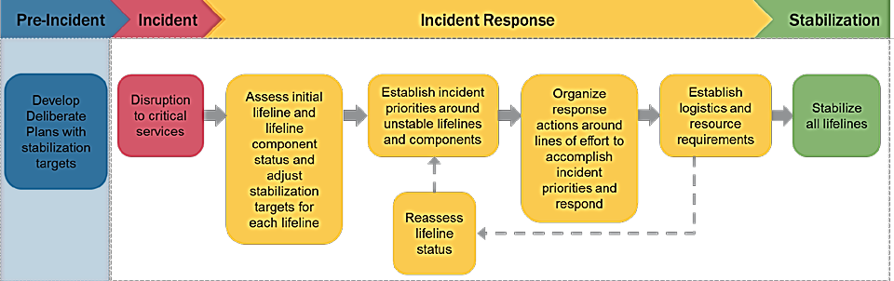FIGURE 18. APPLICATION OF COMMUNITY LIFELINES TO SUPPORT EMERGENCY Management

### INCORPORATING COMMUNITY LIFELINES INTO RESPONSE

FEMA After-Action Reports (AARs) identified the need to create a new operational prioritization and response tool which would:

* Characterize the incident and identify the root causes of priority issue areas in order to create effective solutions.
* Distinguish the highest priorities and most complex issues from other incident information

### COMMUNITY LIFELINE IMPLEMENTATION

The community lifelines reframe incident information to provide decision-makers with impact statements and root causes. This construct maximizes the effectiveness of federally supported, state managed and locally executed response.

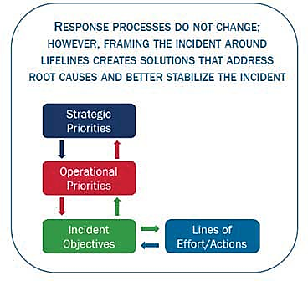Incorporating the lifelines primarily impacts how incident information is organized and reported during response.

Response operations procedures such as NIMS and ICS remain fundamentally the same.

Some changes may include:

* How we understand, prioritize, and communicate incident impacts.
* The structure and format of decision-making support products (e.g., briefings).
* Planning for incident impacts and stabilization both prior to and during incidents.

The interrelationship of Lifelines, Core Capabilities and ESFs can be thought of in terms of **means,** **ways** and **ends.**

**ESFs** and other organizing bodies—**the means**—are the way we organize across departments and agencies, community organizations and industries to enhance coordination and integration to deliver the Response Core Capabilities.

**Response Core Capabilities** describes the grouping of response actions—**the ways**—that can be taken to stabilize and re-establish the lifelines. FEMA executes Lines of Effort (LOE) to operationalize the Core Capabilities (the ways) for response and recovery planning and operations.

**Lifelines** describe the critical services within a community that must be stabilized or re-established to alleviate threats to life and property.

## DECONSTRUCTING THE LIFELINES

Each lifeline is comprised of several components that represent the bucketing of critical Essential Elements of Information (EEIs). The EEIs are the questions we must answer to determine the status of a lifeline.

Components include key capabilities or services that are essential to stabilizing an incident and in providing resources to survivors.

Components are assessed individually to determine the seven lifelines’ status and

**Note:** Not every incident will impact all of the lifelines or components.

FIGURE 18. ORGANIZATION AND BREAKDOWN OF EACH LIFELINE

FIGURE 19. LIFELINE COMPONENTS AND ESSENTIAL ELEMENTS OF INFORMATION (EEI’S)

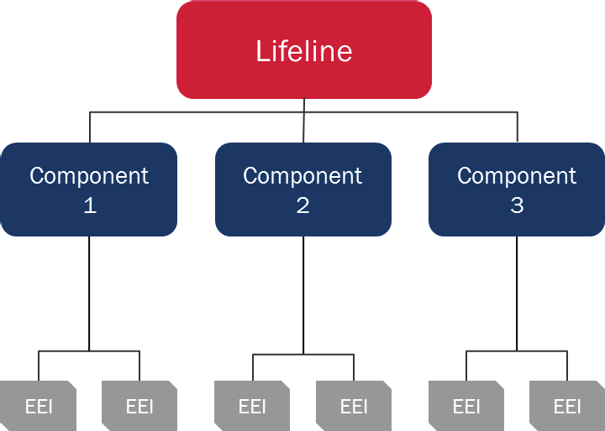

**ORGANIZATION AND BREAKDOWN OF EACH LIFELINE**

|  |  |  |  |  |  |
| --- | --- | --- | --- | --- | --- |
| **LIFELINE SAFETY AND SECURITY** | **DEFINITION** | | | | |
| P3929C3T20#y1 | Law enforcement and government services, as well as the associated assets that maintain communal security, provide search and rescue, evacuations, firefighting capabilities and promote responder safety. | | | | |
| **COMPONENTS AND ESSENTIAL ELEMENTS OF INFORMATION (EEIS)** | | | | | |
| **HAZARD MITIGATION** overall progress of incident response. | | | | **LAW ENFORCEMENT/SECURITY** | | |
| * Status of flood risk grants * Status of area dams, levees, reservoirs | | | | * Evacuation routes * Force protection and security for staff * Security assessments at external facilities * Damaged law enforcement or correctional facilities. | | |
| **RESPONDER SAFETY** | | | | **SEARCH AND RESCUE** | | |
| * Safety hazards affecting operations. * Requirements for personnel protective equipment * Security issues or concerns * Availability and distribution of equipment * Billeting and sustenance for responders * Onsite training and policy | | | | * Number and location of missing survivors * Life threatening hazards to responders and survivors * Availability and resources of search and rescue teams * Status of animal assists, structural assessments, and shelter in place checks | | |
| **FIRE SERVICES** | | | | **GOVERNMENT SERVICES** | | |
| * Location of fire * Percent of fire contained. * Fire’s rate and direction of spread * Weather conditions * Availability and resources of fire services * Evacuation routes | | | | * Status of government offices and schools * Status of continuity of government and continuity of operations * Curfew | | |
| **LIFELINE FOOD, WATER, SHELTER** | | **DEFINITION** | | | | |
| P3976C3T21#y1 | | Support systems that enable the sustainment of life, such as water treatment, transmission, and distribution systems; food retail and distribution networks; wastewater collection and treatment systems; as well as sheltering and agriculture. | | | | |
| **COMPONENTS AND ESSENTIAL ELEMENTS OF INFORMATION (EEIS)** | | | | | | |
| **FOOD/POTABLE WATER** | | | **EVACUATIONS** | | **SHELTER** | |
| * Status of Points of Distribution (PODs) * Operating status of supermarkets, neighborhood markets and grocery stores * Operating status of restaurants * Impacts to the food supply chain. * Operating status of public and private water supply systems * Operating status of water control systems (i.e., dams, levees, storm drains) * Food/water health advisories | | | * Mandatory or voluntary evacuation orders * Number of people evacuating. * Evacuation routes * Evacuation time frame * Risk to responders and evacuees * Food, water, shelter availability | | * Requirements for emergency shelter * Number of open shelters and location * Current population in shelters * Transitional Sheltering Assistance options * Potential future sheltering requirements | |
| **WATER INFRASTRUCTURE** | | | **DURABLE GOODS** | | **AGRICULTURE INFRASTRUCTURE** | |
| * Operating status of public wastewater systems and private septic systems * Operating status of wastewater processing facilities * Operating status of public and private water infrastructure | | | * Need for PODs * Pre-designated POD locations * Operating status of PODs * Resource distribution at PODs | | * Status of area agricultural infrastructure * Status of area supply lines | |

|  |  |
| --- | --- |
| **LIFELINE HEALTH AND MEDICAL** | **DEFINITION** |
| P4024L68C3T22#y1 | Infrastructure and service providers for medical care, public health, patient movement, fatality management, behavioral health, veterinary support and health or medical supply chains. |

|  |  |
| --- | --- |
| **COMPONENTS AND ESSENTIAL ELEMENTS OF INFORMATION (EEIS)** | |
| **MEDICAL CARE** | **PATIENT MOVEMENT** |
| * Status of acute medical care facilities (i.e., level 1 trauma center) * Status of chronic medical care facilities (i.e., long term care centers) * Status of primary care and behavioral health facilities * Status of home health agencies * Status of VA Health System resources in the affected area | * Status of state and local EMS systems * Active patient evacuations * Future patient evacuations |
| **PUBLIC HEALTH** | **MEDICAL INDUSTRY** |
| * Status of pharmaceutical supply chain * Public health advisories | * Status of state and local health departments |
| **FATALITY MANAGEMENT** | |
| * Availability of mortuary and post-mortuary services * Availability of transportation, storage, and disposal resources * Status of body recovery and processing * Descendant’s family assistance | |

|  |  |  |
| --- | --- | --- |
| **LIFELINE ENERGY (POWER & FUEL)** | **DEFINITION** | |
| P4061C3T24#y1 | Service providers for electric power infrastructure, composed of generation, transmission, and distribution systems, as well as gas and liquid fuel processing, transportation, and delivery systems. Disruptions can have a limiting effect on the functionality of other community lifelines. | |
| **COMPONENTS AND ESSENTIAL ELEMENTS OF INFORMATION (EEIS)** | | |
| **POWER (GRID)** | **TEMPORARY POWER** | **FUEL** |
| * Status of electrical power generation and distribution facilities * Number of people and locations without power * Estimated time to restoration of power * Number of electrically dependent persons * Status of nuclear power plants * Status of nuclear power plants within 10 miles * Status of natural gas and fuel pipelines in the affected area | * Status of critical facilities * Availability of temporary power resources | * Status of commercial fuel stations * Responder fuel availability * Status of critical fuel facilities * Status of fuel supply line |

|  |  |  |  |
| --- | --- | --- | --- |
| **LIFELINE COMMUNICATIONS** | **DEFINITION** | | |
| P4097C3T25#y1 | Infrastructure owners and operators of broadband Internet, cellular networks, landline telephony, cable services (to include undersea cable), satellite communications services and broadcast networks (radio and television). Communication systems encompass a large set of diverse modes of delivery and technologies, often intertwined but largely operating independently. Services include elements such as alerts, warnings, and messages, as well as 911 and dispatch. Also includes accessibility of financial services. | | |
| **COMPONENTS AND ESSENTIAL ELEMENTS OF INFORMATION (EEIS)** | | | |
| **INFRASTRUCTURE** | | **ALERTS, WARNINGS and MESSAGES** | **911 AND DISPATCH** |
| * Status of telecommunications service * Reliability of internet service * Reliability of cellular service * Requirements for radio/satellite communication capability | | * Status of the emergency alert system (TV, radio, cable, cell) * Status of public safety radio communications * Options for dissemination of information to the whole community * External affairs and media communication | * Status of phone infrastructure and emergency line * Number of callers and availability of staff and facilities * Status of responder communications * Availability of communications equipment |
| **RESPONDER COMMUNICATIONS** | | | |
| * Status of EOC(s) and dispatcher communications * Availability of responder communications equipment | | | |

|  |  |  |  |
| --- | --- | --- | --- |
| **LIFELINE TRANSPORTATION** | **DEFINITION** | | |
| P4137C3T26#y1 | Multiple modes of transportation often serve complementary functions and create redundancy, adding to the inherent resilience in overall transportation networks. Transportation infrastructure generally includes highway/roadways, mass transit, railway, aviation, maritime, pipeline and intermodal systems. | | |
| **COMPONENTS AND ESSENTIAL ELEMENTS OF INFORMATION (EEIS)** | | | |
| **HIGHWAY / ROADWAY MOTOR VEHICLE** | | **MASS TRANSIT** | **RAILWAY** |
| * Stats of major roads and highways * Status of critical and non-critical bridges * Status of maintenance and emergency repairs | | * Status of public transit systems including underground rail, buses, and ferry services | * Status of area railways and stations |
| **AVIATION** | | **MARITIME** | **PIPELINE** |
| * Status of area airports * Status of incoming and outgoing flights | | * Status of area waterways * Status of area ports | * Status of natural gas and fuel pipelines |

|  |  |  |  |
| --- | --- | --- | --- |
| **LIFELINE HAZARDOUS MATERIALS** | | **DEFINITION** | |
| P4181C3T27#y1 | | Systems that mitigate threats to public health/welfare and the environment. This includes assessment of facilities that use, generate and store hazardous substances, as well as specialized conveyance assets and efforts to identify, contain and remove incident debris, pollution, contaminants, oil, or other hazardous substances. | |
| **COMPONENTS AND ESSENTIAL ELEMENTS OF INFORMATION (EEIS)** | | | |
| **FACILITIES** | **INCIDENT DEBRIS, POLLUTANTS, CONTAMINANTS** | | **CONVEYANCE** |
| * Status of hazardous material facilities * Amount, type, and containment procedures of hazardous materials * Reported or suspected hazardous material/toxic release incidents * Status of hazardous material supply chain | * Debris issues affecting the transportation system. * Status of debris clearance operations * Reported or suspected hazardous material/toxic release incidents * Actual or potential radiological or nuclear incidents * Monitoring actions planned or underway for HAZMAT incidents. | | * Amount and type of hazardous material to remove. * Availability of resources to support conveyance. * Status of transportation, especially freight and pipeline |

### INCIDENT STABILIZATION

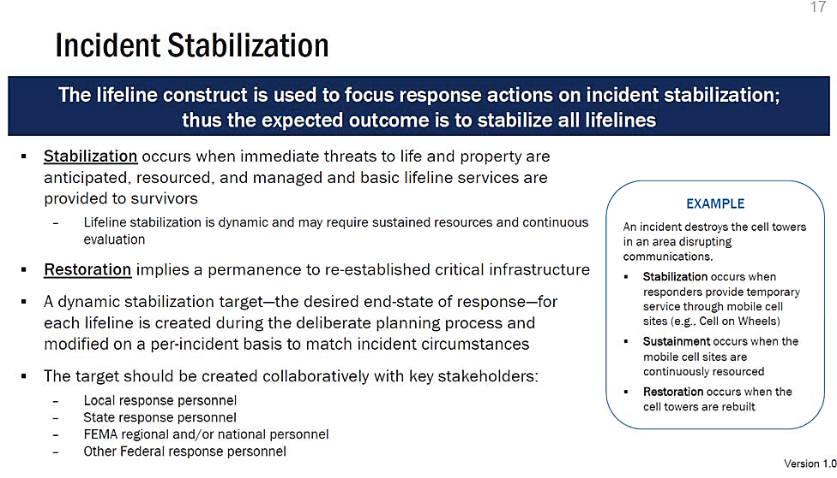

### DETERMINING LIFELINE STATUS

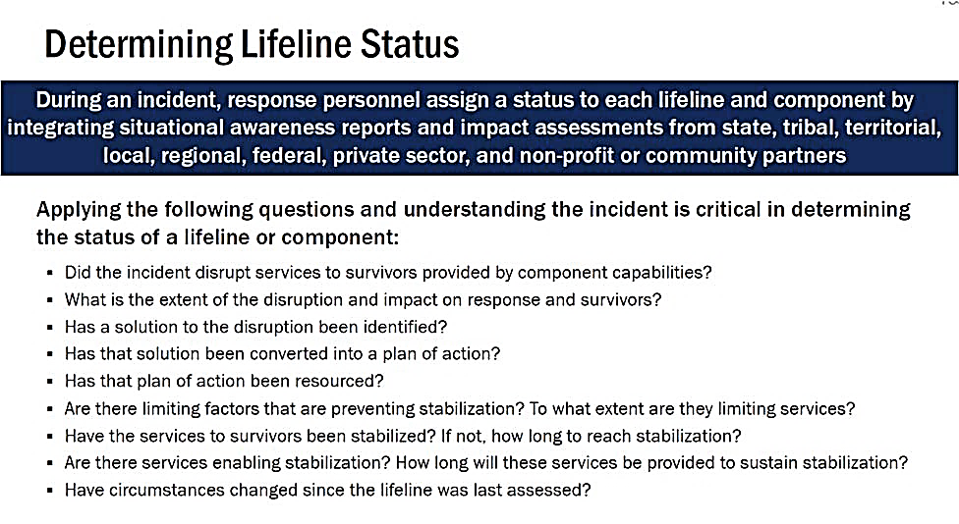FIGURE 20. EXAMPLE OF HOW LIFELINES DRIVE RESPONSE

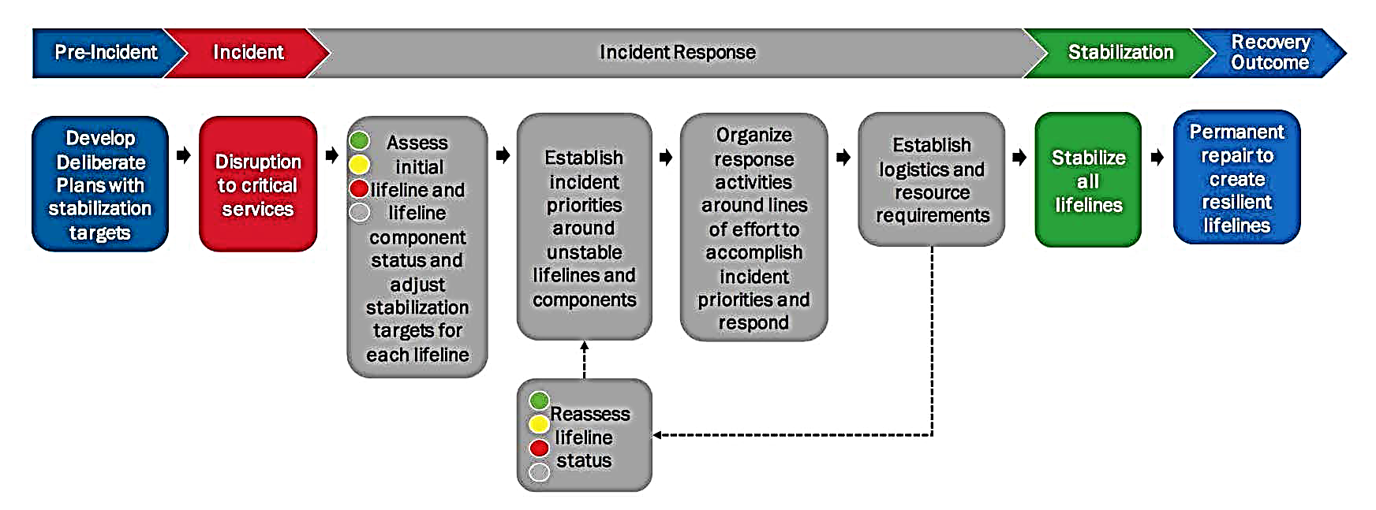

**INCIDENT RESPONDERS ASSESS LIFELINE STATUS, ESTABLISH PRIORITIES**

**ORGANIZE LINES OF EFFORT and RESPOND UNTIL THE INCIDENT IS STABILIZED**

### FIGURE 21. PROGRESSION OF LIFELINE CONDITIONS BEYOND STABILIZATION INTO RECOVERY

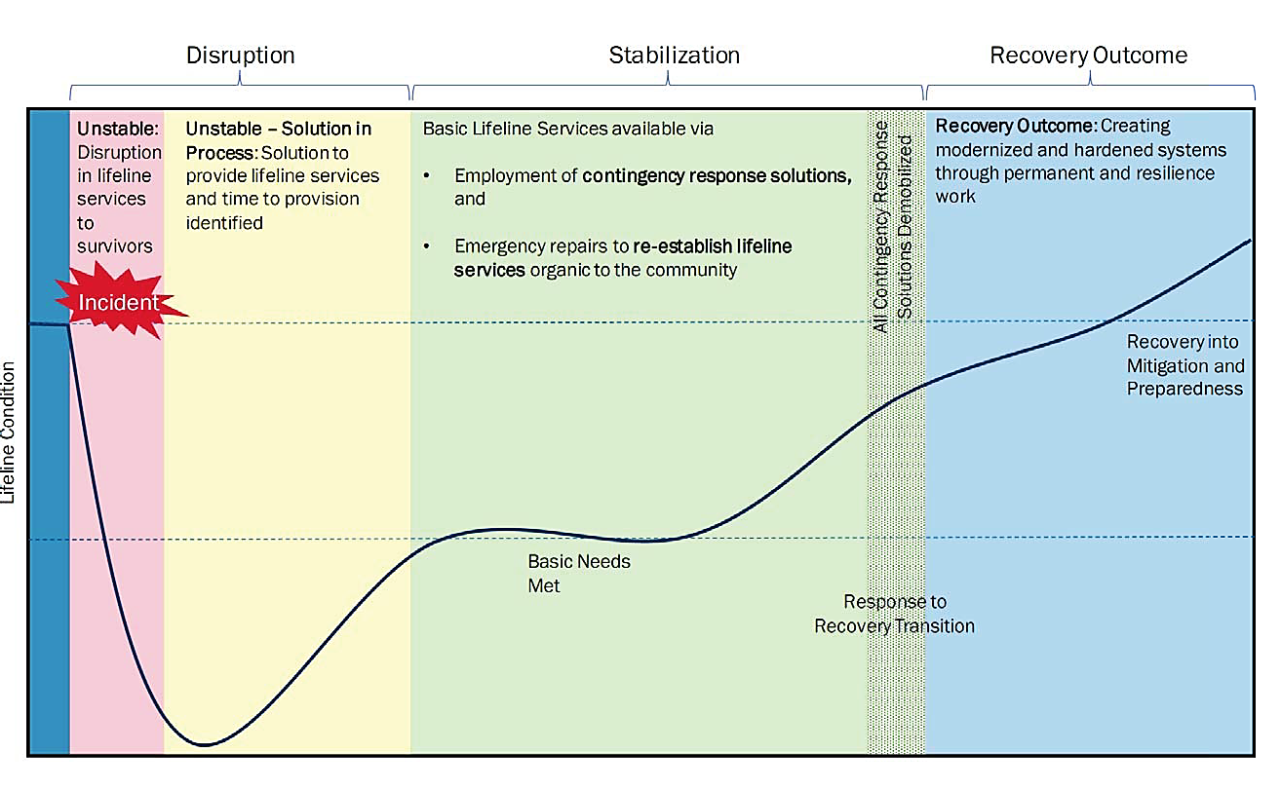

## COLORS INDICATE LIFELINE OR COMPONENT STATUS

**STABLE: Green**

* Minimal or no disruption in services to survivors
* ***Note: Green components may still be severely impacted***

**STABILIZING: Yellow**

* Disruption to services provided by component capabilities is causing limited impacts to response efforts and survivors.
* A solution to the disruption has been identified and has been converted into a plan of action, resourced, and implemented.
* **Limiting factors** may inhibit response.

**UNSTABLE: Red**

* Disruption to services provided by component capabilities is causing significant impacts to response efforts and survivors.
* Requirements and solutions are not identified and/or there is no plan to deliver the solutions.
* **Significant limiting** factors may inhibit response.

**UNKNOWN: Grey**

* Impacts are unknown and/or extent of situation or necessary response is unknown.

### ASSIGNING A STATUS

Assign lifeline statuses as incident circumstances evolve and through the course of response operations.

Stabilization targets will provide the baseline against which lifelines can be compared.

The flowchart shows an example of how responders may think through assigning lifelines a color status.

### FIGURE 22. STATUS ASSIGNMENT FLOWCHART

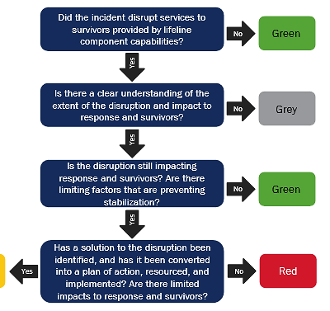

**Yellow**

the disruption still

# ANNEX D – ACRONYMS

|  |  |  |  |
| --- | --- | --- | --- |
| **ACRONYM** | **DESCRIPTION** | **ACRONYM** | **DESCRIPTION** |
| **AAR** | After Action Reports | **DNR** | Department of Natural Resources |
| **ADA** | Americans with Disabilities Act | **DOT** | US Department of Transportation |
| **ARC** | American Red Cross | **DPC** | District Planning Council |
| **BOAH** | Board of Animal Health | **DPOC** | District Planning Oversight Committee |
| **CBRNE** | Chemical, Biological,  Radiological, Nuclear and Explosive | **DRF** | Disaster Relief Fund |
| **CDC** | Centers for Disease Control  and Prevention | **DRTF** | District Response Task Force |
| **CFO** | Chief Financial Officer | **DWD** | Department of Workforce Development |
| **CI/KR** | Critical Infrastructure /Key  Resource | **EAP** | Emergency Action Plan |
| **C-MIST** | Communication, Maintaining health, Independence, Support and Safety and  Transportation | **EMAP** | Emergency Management Accreditation Program |
| **COAD** | Community Organizations  Active in Disaster | **EEG** | Exercise Evaluation Guide |
| **COG** | Continuity of Government | **EEI** | Essential Elements of Information |
| **COML** | Communications Unit Leader | **EM** | Emergency Management |
| **CONOPS** | Concept of Operations | **EMA** | Emergency Management  Agency |
| **COOP** | Continuity of Operations | **EMAC** | Emergency Management  Assistance Compact |
| **CPG** | Comprehensive Preparedness  Guide | **EMS** | Emergency Medical Services |
| **CPRI** | Calculated Priority Risk Index | **EO** | Executive Order |
| **DECON** | Decontamination | **EOC** | Emergency Operations Center |

|  |  |  |  |
| --- | --- | --- | --- |
| **ACRONYM** | **DESCRIPTION** | **ACRONYM** | **DESCRIPTION** |
| **EOP** | Emergency Operations Plan | **IDHS** | Indiana Department of Homeland Security |
| **ESF** | Essential Support Function | **IDOA** | Indiana Department of Administration |
| **FAA** | Federal Aviation Administration | **IDOC** | Indiana Department of Corrections |
| **FCO** | Federal Coordinating Officer | **IDOE** | Indiana Department of Education |
| **FDA** | Food & Drug Administration | **IDOH** | Indiana Department of Health |
| **FC-DHSEM** | Fayette County Department of Homeland Security and Emergency Management | **IDOI** | Indiana Department of Insurance |
| **FEMA** | Federal Emergency Management Agency | **IDOL** | Indiana Department of Labor |
| **FOUO** | For Official Use Only | **IEDC** | Indiana Economic Development Corporation |
| **FSE** | Full Scale Exercise | **IHCDA** | Indiana Housing and Community Development Authority |
| **FSSA** | Family and Social Services Administration | **IIFC** | Indiana Intelligence Fusion Center |
| **HAZMAT** | Hazard Material | **IMAT** | Indiana Management Assistance Team |
| **HAZUS** | Hazards United States | **INDOT** | Indiana Department of Transportation |
| **HHS** | US Health and Human Services | **INNG** | Indiana National Guard |
| **HIRA** | Hazard Identification & Risk Assessment | **IN-TF1** | Indiana Task Force One |
| **HSEEP** | Homeland Security Exercise Evaluation Program | **IN-VOAD** | Indiana Voluntary Organizations Active in Disaster |
| **HSIN** | Homeland Security Information Network | **IOSHA** | Indiana Occupational Safety and Health Administration |
| **HSPD-5** | Homeland Security Presidential Directive 5 | **IOT** | Indiana Office of Technology |
| **IAP** | Incident Action Plan | **IP** | Improvement Plan |
| **IC** | Incident Command | **IPAWS** | Integrated Public Alert & Warning System |
| **ICP** | Incident Command Post | **IPPW** | Integrated Preparedness Planning Workshop |
| **ICS** | Incident Command System |  |  |

|  |  |  |  |
| --- | --- | --- | --- |
| **ACRONYM** | **DESCRIPTION** | **ACRONYM** | **DESCRIPTION** |
| **IPSC** | Integrated Public Safety Commission | **POETE** | Plan, Organize, Equip, Train, Exercise |
| **ISEP** | Indiana State Excise Police | **PPD-8** | Presidential Policy Directive - 8 |
| **ISP** | Indiana State Police | **PSAP** | Public Safety Answering Point |
| **IURC** | Indiana Utility Regulatory Commission | **RACES** | Radio Amateur Civil Emergency Service |
| **JFO** | Joint Field Office | **REPP** | Radiological Emergency Preparedness Program |
| **JIC** | Joint Information Center | **RND** | Radiological Nuclear Detection |
| **JOC** | Joint Operations Center | **RRCC** | Regional Response Coordination Center |
| **JTTF** | Joint Terrorism Task Force | **SAA** | State Administrative Agency |
| **MOA** | Memorandum of Agreement | **SBA** | Small Business Administration |
| **MOU** | Memorandum of Understanding | **SEOC** | State Emergency Operations Center |
| **MRC** | Medical Reserve Corps | **SHMP** | State Hazard Mitigation Program |
| **MUTC** | Muscatatuck Urban Training Center - INNG | **SOG** | Standard Operating Guideline |
| **NEMA** | National Emergency Management Association | **SOP** | Standard Operating Procedure |
| **NEMSIS** | National EMS Information System | **SPD** | State Personnel Department |
| **NGO** | Non-Governmental Organization | **SPR** | Stakeholder Preparedness Review |
| **NIMS** | National Incident Management System | **THIRA** | Threat and Hazard Identification and Risk Assessment |
| **NIPSCO** | Northern Indiana Public Service Company (Utility) | **TTX** | Table-Top Exercise |
| **NWS** | National Weather Service | **UASI** | Urban Areas Security Initiative |
| **OCRA** | Office of Community and Rural Affairs | **UC** | Unified Command |
| **OMB** | Office of Management and Budget | **VOAD** | Voluntary Organizations Active in a Disaster |
| **PIO** | Public Information Officer | **WEBEOC** | Web Emergency Operations Center |

# ANNEX E – TERMS AND DEFINITIONS

|  |  |
| --- | --- |
| **TERM** | **DEFINITION** |
| **Access and Functional Needs** | Persons who may have additional needs before, during and after an incident in functional areas, including but not limited to maintaining health, independence, communication, transportation, support, services, self-determination, and medical care. Individuals in need of additional response assistance may include those who have disabilities; live in institutionalized settings; are older adults; are children; pregnant women, people with temporary injuries; are from diverse cultures; have limited English proficiency or are non-English speaking; or are transportation disadvantaged |
| **Agency** | A division of government with a specific function offering a particular kind of assistance. In ICS, agencies are defined either as jurisdictional (having statutory responsibility for incident management) or as cooperating (providing resources or other assistance). |
| **All-Hazard** | A threat or an incident, natural or manmade, that warrants action to protect life, property, the environment and public health or safety and to minimize disruptions of government, social, or economic activities. It includes natural disasters, cyber incidents, industrial accidents, pandemics, acts of terrorism, sabotage and destructive criminal activity targeting critical infrastructure. This also includes the effects climate change has on the threats and hazards. |
| **Area Command / Unified Area Command** | Area Command (Unified Area Command). An organization established (1) to oversee the management of multiple incidents that are each being handled by an ICS organization or (2) to oversee the management of large or multiple incidents to which several Incident Management Teams have been assigned. Area Command has the responsibility to set overall strategy and priorities, allocate critical resources according to priorities, ensure that incidents are properly managed and ensure that objectives are met, and strategies followed. Area Command becomes Unified Area Command when incidents are multi-jurisdictional. Area Command may be established at an EOC facility or at some location other than an ICP. |
| **Cascading Effects** | Cascading effects are the dynamics present in disasters, in which the impact of a physical event or the development of an initial technological or human failure generates a sequence of events in human subsystems that result in physical, social, or economic disruption. Thus, an initial impact can trigger other phenomena that lead to consequences with significant magnitudes. |
| **Casualty** | Any person who is declared dead or is missing, ill, or injured. |
| **Chain of Command** | A series of command, control, executive, or management positions in hierarchical order of authority. |
| **Command Staff** | In an incident management organization, the Command Staff consists of the Incident Command and the special staff positions of Public Information Officer, Safety Officer, Liaison Officer, and other positions as required, who report directly to the Incident Commander. They may have an assistant or assistants, as needed. |
| **Community Lifelines** | A lifeline enables the continuous operation of critical government and business functions and is essential to human health and safety or economic security. The integrated network of assets, services and capabilities that provide lifeline services are used day-to-day to support the recurring needs of the community and enable all other aspects of society to function. |
| **Concept of Operations** | A concept of operations (CONOPS) is a high-level description of the actions to be taken in the pursuit of mission accomplishment. |
| **Core Capabilities** | 32 distinct critical elements necessary to achieve the National Preparedness Goal. |
| **Critical Infrastructure** | Systems and assets, whether physical or virtual, so vital to the United States that the incapacity or destruction of such systems and assets would have a debilitating impact on security, national economic security, national public health or safety, or any combination of those matters. The Nation’s critical infrastructure is composed of 16 sectors: chemical; commercial facilities; communications; critical manufacturing; dams; defense industrial base; emergency services; energy; financial services; food and agriculture; government facilities; healthcare and public health; information technology; nuclear reactors, material, and waste; transportation systems; and water and wastewater systems. |
| **Cybersecurity** | The process of protecting information by preventing, detecting, and responding to attacks. |
| **Emergency Operations Center (EOC)** | The physical location at which the coordination of information and resources to support domestic incident management activities normally takes place. An EOC may be a temporary facility or may be in a more central or permanently established facility, perhaps at a higher level of organization within a jurisdiction. EOCs may be organized by major functional disciplines (e.g., fire, law enforcement and medical services), by jurisdiction (e.g., Federal, State, regional, county, city, tribal), or by some combination thereof. |
| **Emergency Operations Plan (EOP)** | The “steady-state” plan maintained by various jurisdictional levels for managing a wide variety of potential hazards. |
| **Emergency Support Function (ESF) Point of Contact** | The Emergency Support Function (ESF) Point of Contact coordinates the responsibilities between the Primary Agency supporting the State Emergency Operations Center (SEOC) and the specific ESF. |
| **Exercise** | Exercise enables testing of plans, procedures, protocols, internal coordination and practicing coordination with external response entities. Depending on the scope and scale of the emergency preparedness exercises, they may involve many individuals, both internal and external. Exercises can be discussion-based or operational-based. |
| **Incident** | An occurrence or event (natural, technological, or human-caused), that requires a response to protect life, property, or the environment. Examples include major disasters, emergencies, terrorist attacks, terrorist threats, civil unrest, wild land and urban fires, floods, hazardous materials (HAZMAT) spills, pandemics, aircraft accidents, earthquakes, tornadoes, severe thunderstorms, war-related disasters, public health and medical emergencies and other occurrences requiring an emergency response |
| **Mission Areas** | Groups of core capabilities, including Prevention, Protection, Mitigation, Response and Recovery. |
| **Mitigation** | The capabilities necessary to reduce loss of life and property by lessening the impact of disasters. |
| **National Preparedness** | The actions taken to plan, organize, equip, train and exercise to build and sustain the capabilities necessary to prevent, protect against, mitigate the effects of, respond to and recover from those threats that pose the greatest risk to the security of the Nation. |
| **Prevention** | The capabilities necessary to avoid, prevent, or stop a threatened or actual act of terrorism. For the purposes of the prevention framework, the term “prevention” refers to preventing imminent threats. |
| **Protection** | Protect our citizens, residents, visitors and assets against the greatest threats and hazards in a manner that allows our interests, aspirations, and way of life to thrive. |
| **Recovery** | Recover through a focus on the timely restoration, strengthening and revitalization of infrastructure, housing, and a sustainable economy, as well as the health, social, cultural, historic, and environmental fabric of communities affected by an incident. |
| **Resilience** | The ability to adapt to changing conditions and withstand and rapidly recover from disruption due to emergencies. |
| **Response** | Respond quickly to save lives; protect property and the environment; and meet basic human needs in the aftermath of an incident. |
| **Risk Assessment** | A product or process that collects information and assigns a value to risks for the purpose of informing priorities, developing, or comparing courses of action and informing decision making. |
| **Security** | The protection of the Nation and its people, vital interests, and way of life. |
| **Stabilization** | The process by which the immediate impacts of an incident on community systems are managed and contained |
| **Steady State** | A condition where operations and procedures are normal and ongoing. Communities are at a steady state prior to disasters and after recovery is complete. |
| **Terrorism** | Any activity that involves an act that is dangerous to human life or potentially destructive of critical infrastructure or key resources and is a violation of the criminal laws of the United States or of any state or other subdivision of the United States; and appears to be intended to intimidate or coerce a civilian population, or to influence the policy of a government by intimidation or coercion, or to affect the conduct of a government by mass destruction, assassination, or kidnapping. (Note that although the definition of terrorism includes both domestic and international acts of terrorism, the scope of the planning system is the prevention and protection against acts of terrorism in the homeland.) |
| **Weapons of Mass Destruction** | Materials, weapons, or devices that are intended or capable of causing death or serious bodily injury to a significant number of people through release, dissemination, or impact of toxic or poisonous chemicals or precursors, a disease organism, or radiation or radioactivity, to include, but not limited to, biological devices, chemical devices, improvised nuclear devices, radiological dispersion devices and radiological exposure devices. |
| **Whole Community** | A focus on enabling the participation in national preparedness activities of a wider range of players from the private and nonprofit sectors, including non-governmental organizations and the general public, in conjunction with the participation of all levels of government in order to foster better coordination and working relationships. Used interchangeably with “all-of-Nation.” |